Apple’s Newsletter

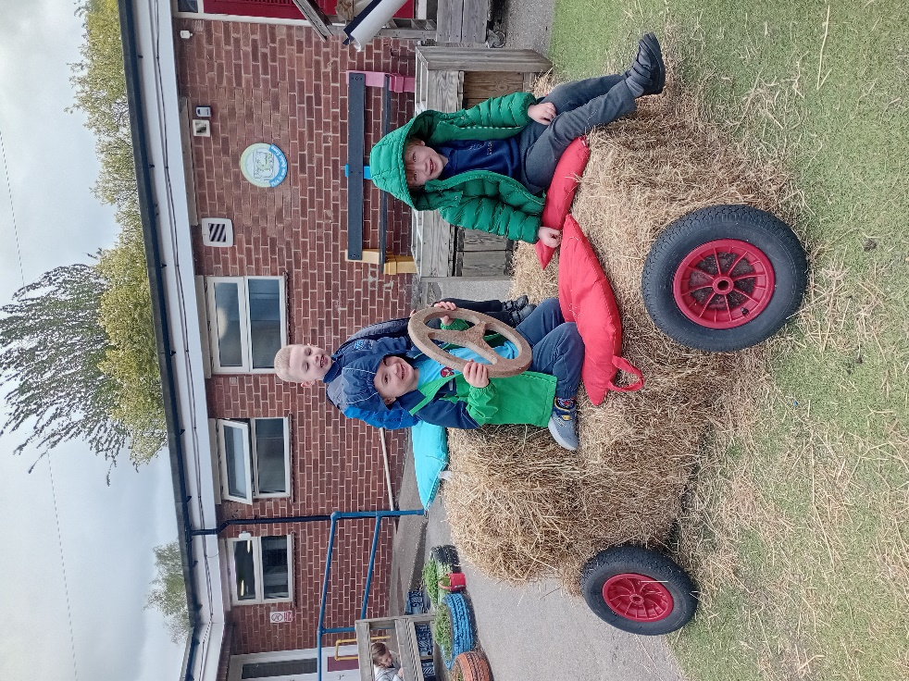

It has been a busy few months in the Apple’s classroom. The children have really enjoyed exploring our topics linking to animals and growing. They have particularly enjoyed making vehicles with our hay bales and using their imagination and creativity to take themselves to the farm or fix the tractors. This half term we are exploring the question ‘How does your garden grow?’. The children have planted cress and wildflower bee bombs, and we are excited to see these grow. Our class bear Appleby has been enjoying his adventures with the children and it has been amazing to see how confidently the children talk about what they got up to in front of the whole class.
All children will be welcome to join us for Sports Day, even if this is not their usual day in Preschool. Further information will be sent out closer to the time.
Some reminders now that we are entering warmer weather, please remember to send your child with a sunhat and suncream and a raincoat. We aim to still use our outdoor area in all weathers. We will also be using the outdoor water area regularly so a spare outfit or waterproofs are helpful for some exciting activities.
Have a lovely weekend
Team Apples

