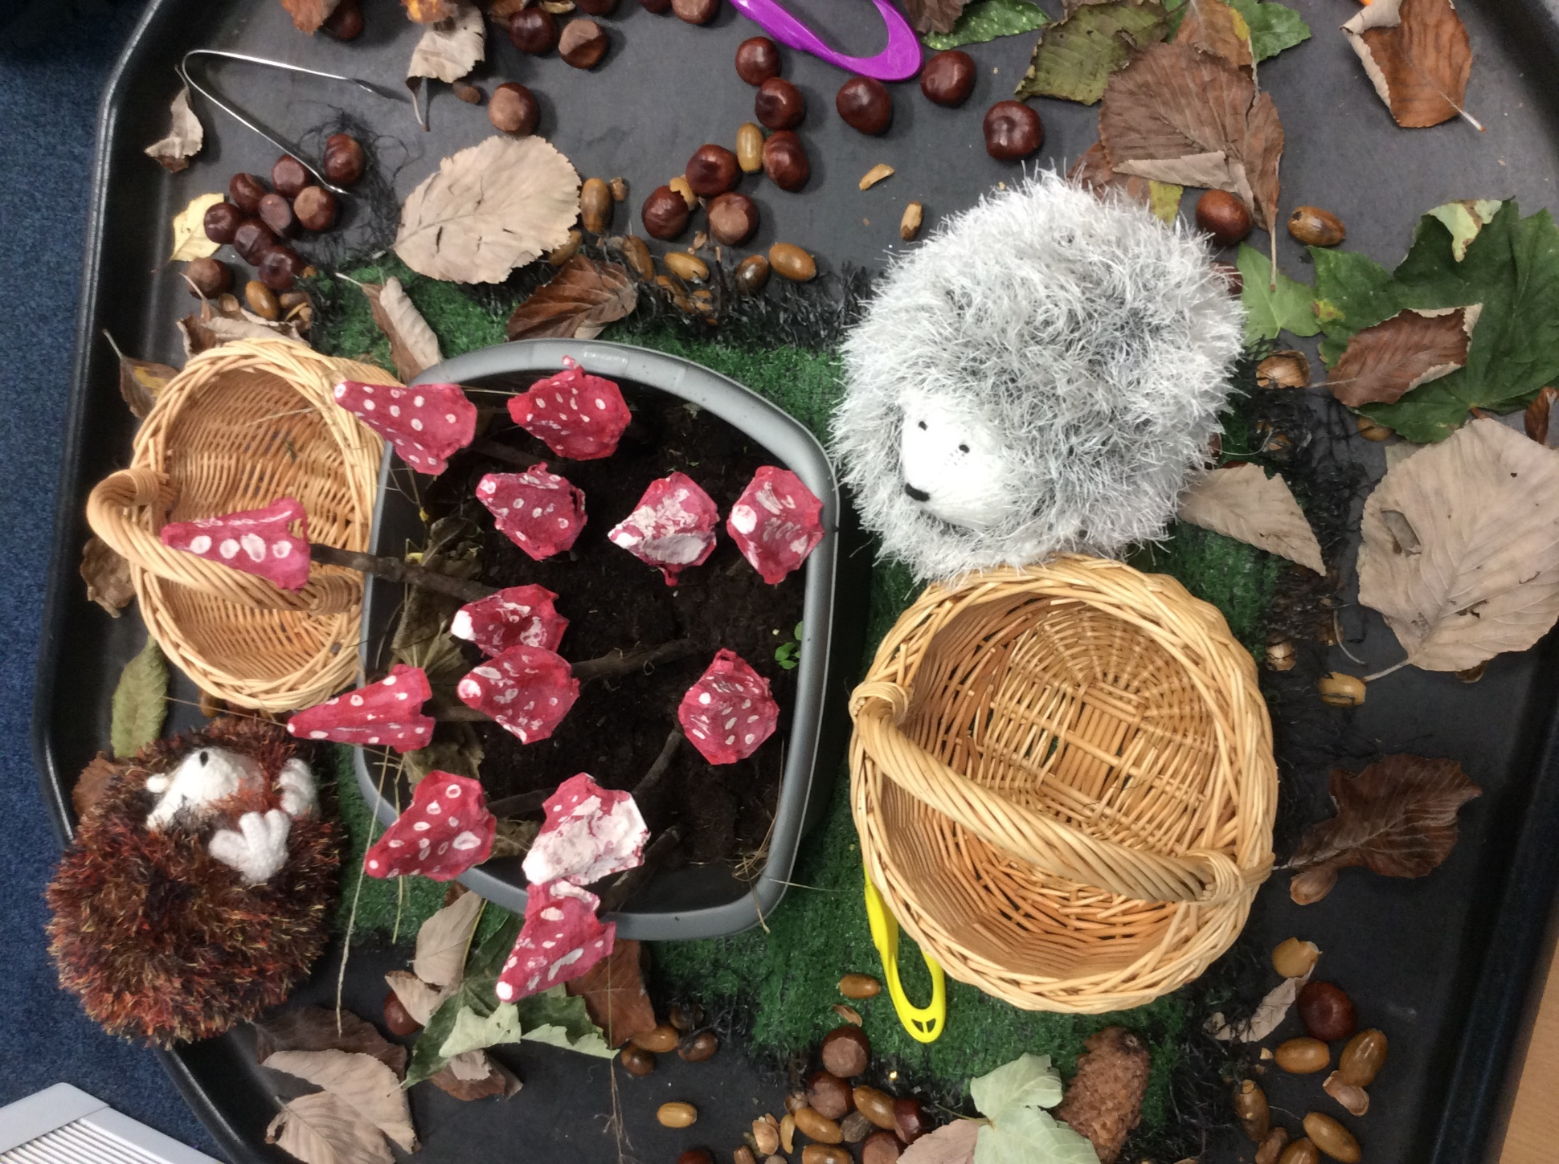
This week our children have enjoyed immersing in activities linked to the book “We’re Going on a Bear Hunt” and the season of Autumn. From a sensory walking trail to creating our very own toadstool garden in the classroom and yoga, they are all really enjoying this topic.
We will be continuing with Autumn for the next few weeks and to help us with this topic, we would love it if you could bring us any autumn leaves that you find whilst out on your walks. There is no such thing as too many leaves for our projects.
From next week, we will be sending our class bear, Appleby, home with one child per week along with a book for recording what he has done and we can’t wait to find out what he gets up to on his adventures with the Apple Class.
A little reminder that Thursday is PE day and your child needs to bring in their PE kit if they attend that day. Please feel free to speak to any of the team members if you have questions.
Miss McGrory, Miss Smith and Mrs Spence (Team Apples)
Apple Class Newsletter

