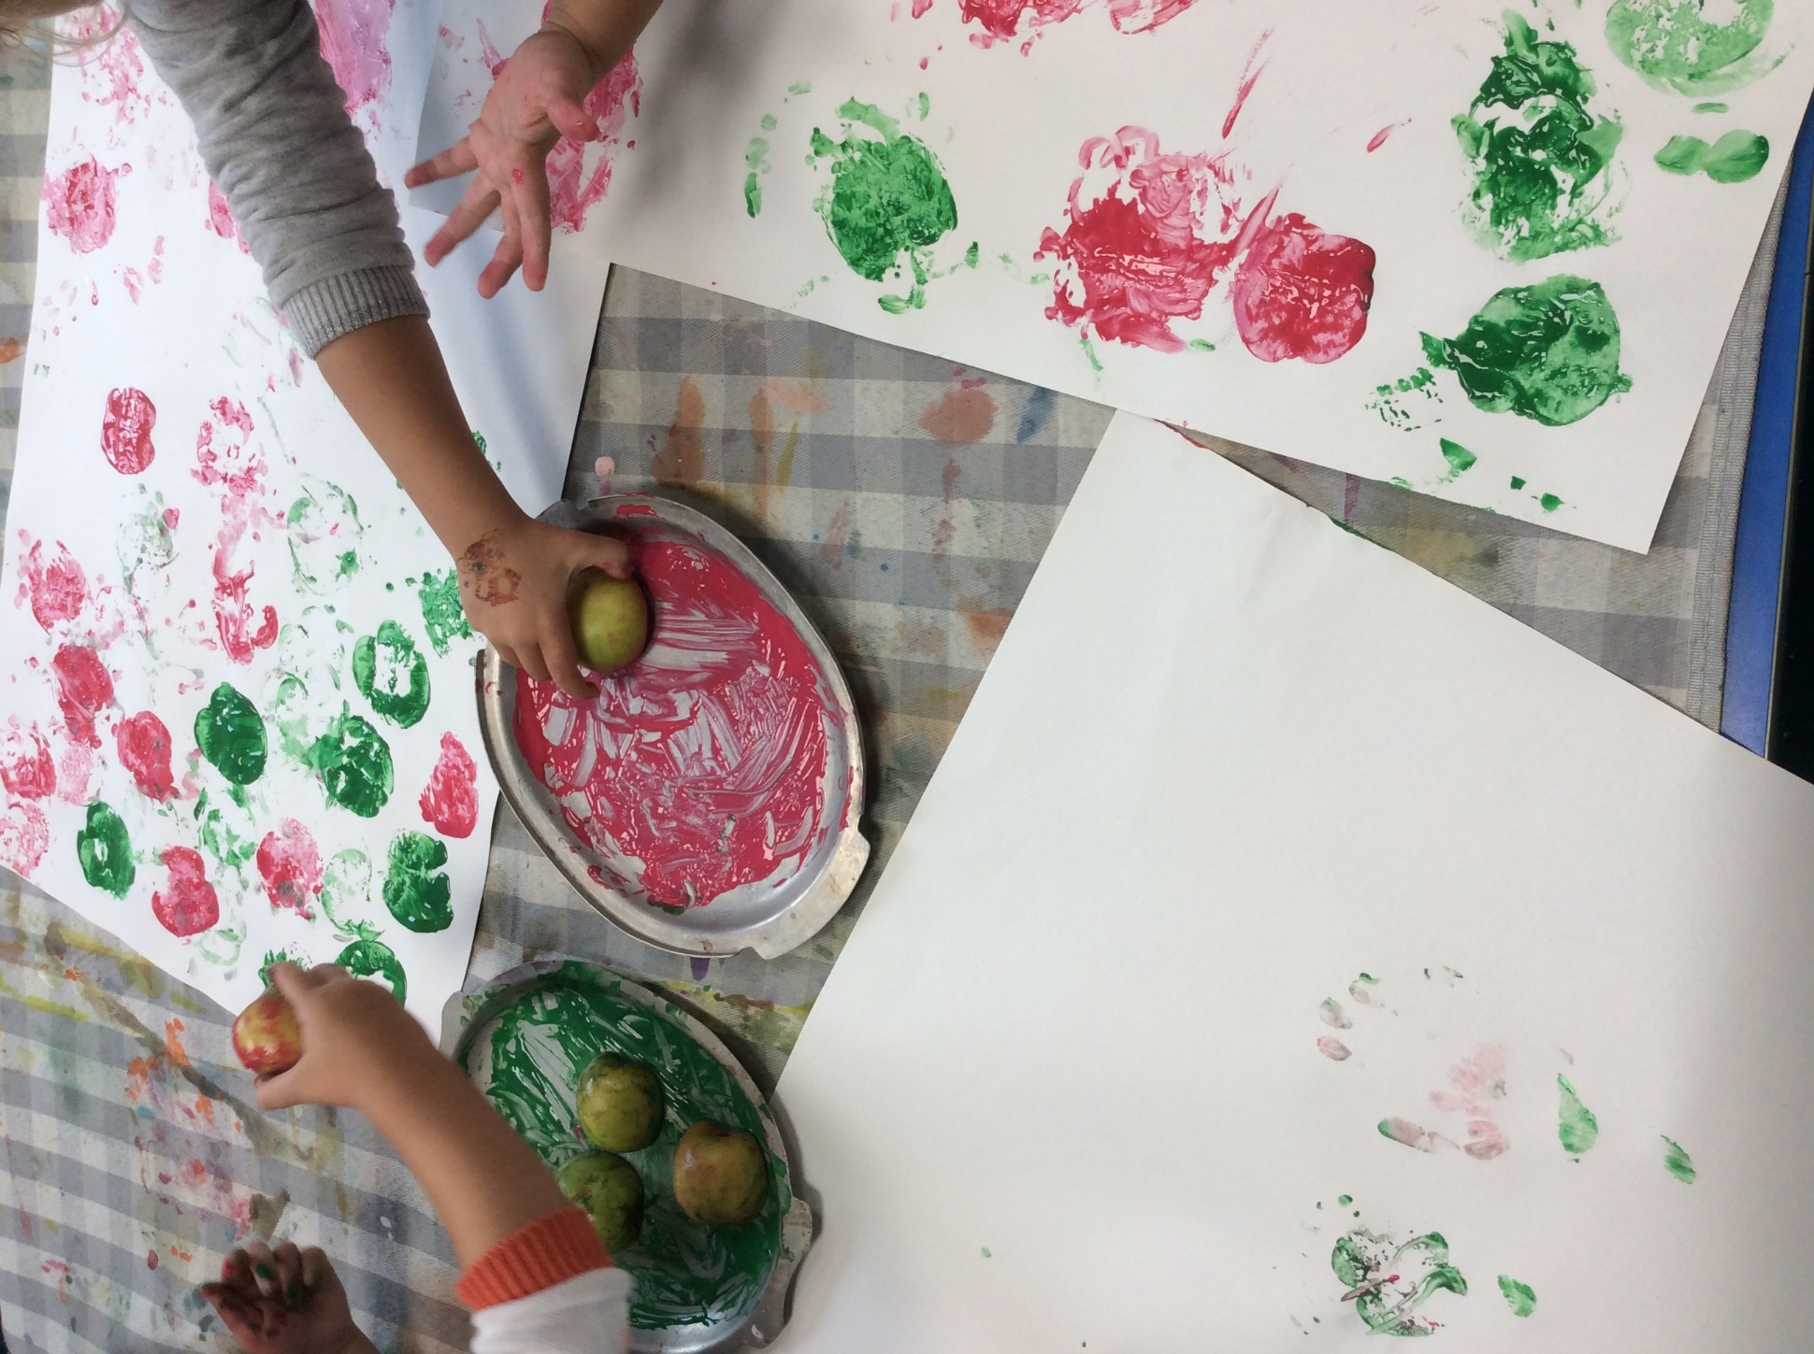
We have really enjoyed the first few weeks getting to know each other in our new classroom. The children have been exploring through various methods and really enjoyed collecting apples from our school apple tree to do some taste testing and apple printing for our entrance display. We are already enjoying books and activities linked to our EYFS curriculum. The rest of this half term, we will be learning about Autumn, Kindness and we have some exciting activities planned for our ‘We’re Going on a Bear Hunt’ theme.
To help us with this topic, we would love it if you could bring us any autumn leaves that you find whilst out on your walks. There is no such thing as too many leaves for our projects.
A little reminder that Thursday is PE day and your child needs to bring in their PE kit if they attend that day. Please feel free to speak to any of the team members if you have any questions.
Miss McGrory, Miss Smith and Mrs Spence (Team Apples)
Apple Class Newsletter

