
Lower KS2 Junior Parent Pack

Welcome to Lower KS2 Juniors. This year, your child will be taught by Miss Waghorn and at times, Mrs Smith and Mrs Williams.

A comprehensive overview of our planning can be found on the school website. Units covered this year are as follows:

English:

Term 1: Settings, recount, suspense and action, persuasive adverts.
Term 2: Dialogue, explanation, opening and endings, discussion.
Term 3: Description -people, places and objects, instructions, character, information.

Maths Year 3:

Term 1: Place Value, Addition and Subtraction, Multiplication and Division A
Term 2: Multiplication and Division B, Length and Perimeter, Fractions A, Mass and Capacity.
Term 3: Fraction B, Money, Time, Shape, Statistics.

Maths Year 4:

Term 1: Place Value, Addition and Subtraction, Measurement and Area, Multiplication and Division A
Term 2: Multiplication and Division B, Length and Perimeter, Fractions, and Decimals A.
Term 3: Decimals B, Money, Time, Shape, Statistics, Position and Direction.

Science:

Term 1: Food and the Digestive System, Sound

Term 2: States of Matter, Grouping and Classifying

Term 3: Electrical Circuits and conductors.

R.E:

Term 1: UC Creation/Fall - What do Christians learn from the creation story? UC Incarnation/God - What is the Trinity?

Term 2: How do Hindu families practise their faith? What are the deeper meanings of some Hindu festivals?
UC Salvation - Why do Christians call the day Jesus died Good Friday?

Term 3: UC Kingdom of God - When Jesus left, what was the impact of Pentecost?
Symbols and Religious Beliefs - How do people express their religions and spiritual ideas on pilgrimages?

Geography:

Term 1: Interconnected World
Term 2: Misty Mountain, Windy River ‘What journey does a drop of water take?’
Term 3: Revision and retrieval practice.

History:

Term 1: Invasion ‘What was the impact of the Anglo-Saxons on Britain?’ and ‘Did the Vikings destroy Anglo-Saxon Britain?’

Term 3: Ancient Civilisation ‘Which Ancient Civilisation would you choose to visit?’

Art:

Term 1: Contrast and Compliment, Warp and Weft
Term 2: Vista, Animal
Term 3: Statues, statuettes and figurines, Islamic Art

D&T:

Term 1: Fresh Food, Good Food
Term 2: Functional and Fancy fabrics
Term 3: Tomb Builders
Spanish:

Term 1: Las formas (Shapes), Los instrumentos (Musical instruments)
Term 2: Las verduras (Vegetables), La historia de la antigua Gran Bretaña (Ancient Britain)
Term 3: La clase (The Classroom) and Hábitats (Habitats)

ICT: Online safety, coding, spreadsheets, touch typing, Email, branching databases, presenting, PowerPoint.

English and Maths will be taught daily, alongside Arithmetic sessions in Maths and reading, spelling and handwriting in English.

Example of weekly timetable: (Sample Year 3/4) * The timetable is flexible and will be changed when necessary.

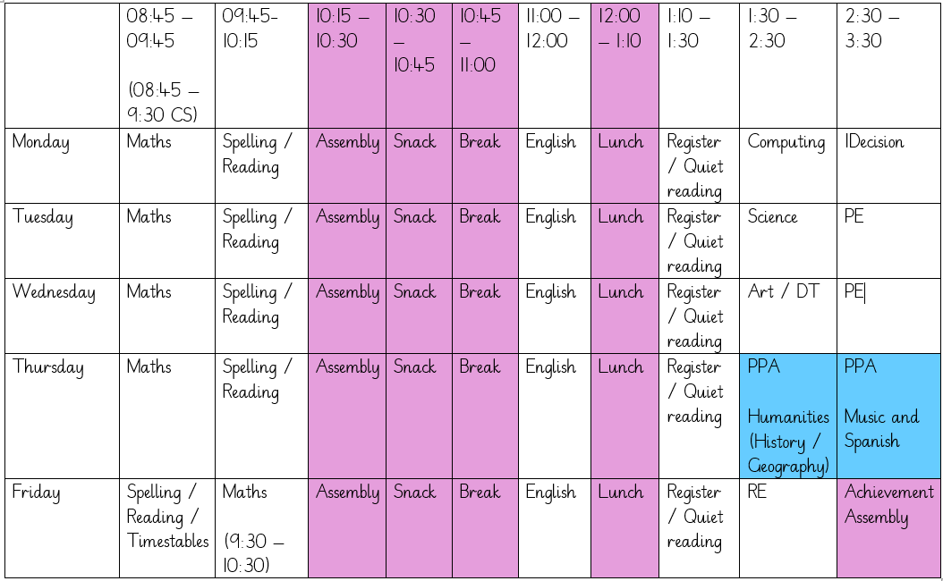

Homework:
We will send work home weekly to support learning in class, for example: Maths work via Maths.Co.Uk. This will be sent on the weeks we do not send home our fortnightly Newsletter. Alternative weeks we shall send either English or topic/ other curriculum work.

The children should be encouraged to go on Timetables Rock stars to help them learn their tables. Tables will be tested each week on a Friday. Usernames and passwords for both Timestables Rocks Star and Maths.co.uk can be found in their work diaries. Finally, we strongly encourage daily reading from a variety of sources. Evidence of reading will earn them Take Care tokens, and bookmarks will be awarded for regular reading.
Year 4 children will be doing a National Times Table test in June.

Spellings:
We are following the ‘No Nonsense’ spelling scheme and this will be taught during SPaG lessons or during a specific timetabled slot. Alongside this we learn the Statutory Year 3/4 spellings; therefore, we will send the Statutory spelling list home fortnightly with the spellings your child needs to learn. By the end of Yr4 the children are expected to have learnt the list (children may work from a different list if the class teacher feels this is more suitable).

Work diary:
School diaries are needed in school EVERY day. We use them to record reading and other information we feel you may need to know. We ask you to fill in when your child has read, practiced spellings and times table and please sign to confirm. Teachers will check diaries on Fridays and will stamp to acknowledge your child’s hard work.

PE:
PE will be on a Tuesday and Wednesday afternoon. For the Autumn term, gymnastics is indoors on a Tuesday and outdoor football on a Wednesday afternoon. PE days will change on a termly basis, we will inform you when this happens.

Take Care Tokens (House Points):

These are rewarded for either good behaviour or outstanding work. Integrity awards are given for those children who go beyond everyday expectations. These can be given by staff, parents both in and out of school. Please let Mr. Tomlinson know if you wish to nominate a child.

TRIPS:
Throughout the year the Lower Juniors will be attending day trips out of school. Parent help is always required for these trips to go ahead.

RESIDENTIALS:

Year 4 will be going to Dukes Barn – 15th – 17th June 2025.

If you have any concerns or just wish to discuss your child’s progress, we are always happy to talk, but can we please ask that you make an appointment via the office. All emails must be sent to the office, and they will forward them on to us.

Thank you,

Miss Waghorn.

