**Movie Quiz**

1. What is the name of the snowman in frozen?
2. How many ugly sisters did Cinderella have?
3. What colour hair does Snow White have?
4. True or false: in lady and the tramp two dogs ate a bowl of spaghetti?
5. How many children does Mary Poppins look after?
6. What magical item does Aladdin fly on?
7. What is the name of the cruel lady in 101 dalmatians?
8. What type of animal is bamby?
9. How many years was sleeping beauty asleep for?
10. What is the name of Simba’s horrible uncle in the lion King: A. Ed B. Raymond C. Scar?

**Geography**

Unscramble the anagram to find the country

1. Lengdna
2. Pinas
3. Negranita
4. Cenfar
5. Panja
6. Acirema
7. Litrusaaa
8. Gineari
9. Kitansap

10.Danilath

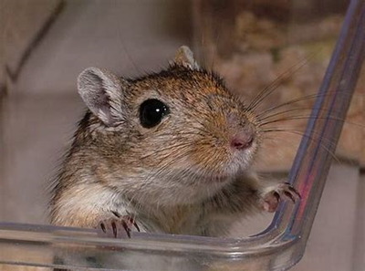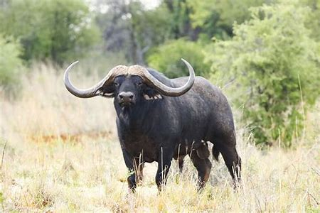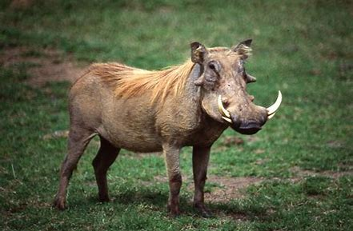[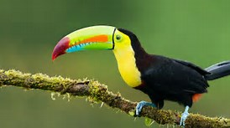](https://www.bing.com/images/search?q=pics+toucan&id=FE56353DD39A33CA0D26DF11E558F44E5937ABA3&FORM=IQFRBA)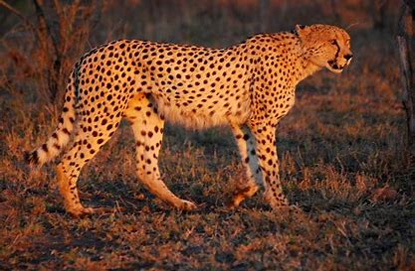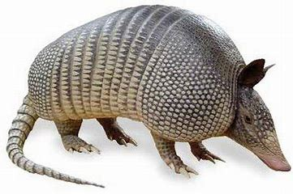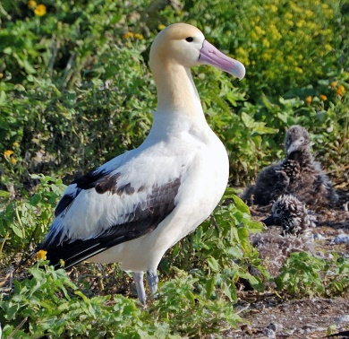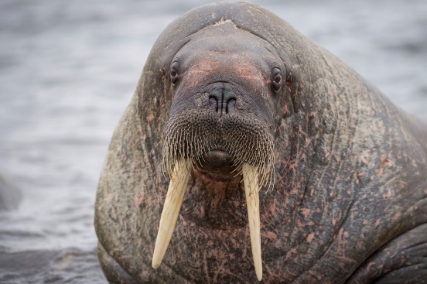Nature – Name the animal

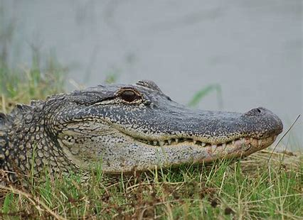

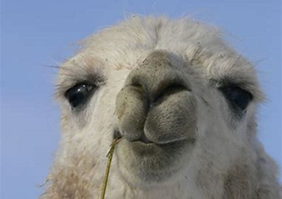

**Sports**

1.When were the first winter Olympics held?

A: 1922 B: 1924 C: 1932 D: 1902

2.Which of the following is NOT a part of the summer Olympics?  
A: Boxing B: Cycling C: Biathlon D: Water Polo

3.Which of the following is not a part of the modern Olympics anymore?  
A: Softball B: Table Tennis C: Taekwondo D: Volleyball

4.Who did the Greeks dedicate the Olympics to?

A: Zeus B: Hera C: Demeter D: Apollo

5.What is the period between Olympic games called?

A: Holiday Break B: Fermata C: Break D: Olympiad

6.From what country originated Olympics?  
A: USA B: Italy C: Greece D: France

7.When were the first modern Olympic Games held?

A: 1888 B:1896 C:1904 D:1912

8.Which nationality is Usain Bolt?  
A: USA B: Great Britain C: Jamaica D: South Africa

9. How many medals did Great Briton win in 2012?

A:65 B:69 C:71 D:75

10.How long is an Olympic sized swimming pool?

A: 25 B: 40 C: 50 D:100

|  |  |  |  |
| --- | --- | --- | --- |
|  |  |  |  |
| **1** | **2** | **3** | **4** |
|  |  |  |  |
| **5** | **6** | **7** | **8** |
|  |  |  |  |
| **9** | **10** | **11** | **12** |
|  |  |  |  |
| **13** | **14** | **15** | **16** |
|  |  |  |  |
| **17** | **18** | **19** | **20** |

Food – Name the chocolate bar