East Bridgford St Peters Climate Action Plan

One year plan: Summer 2024 – Summer 2025

Created in collaboration with Let’s Go Zero

|  |  |  |  |
| --- | --- | --- | --- |
| Potential Carbon Reduction  Leaf outline | Potential Cost Savings  £ | Expected  Cost  £ | Ease of Implementation  Clock outline |

Count Your Carbon baseline: 358.09 Tonnes Co2

Date: 14th March 2024

Updated 18th February 2025

**Appendices:**

* **Gas & electricity comparison graphs**
* **Food (Pro-Veg Award)**
* **Uniform Wardrobe**
* **Curriculum plans – sustainability**

**February 2025**

In a full calendar year, January 2024 to December 2024, you have **reduced your gas use by 10%** **and your electricity use by 8%.**

Using the Count Your Carbon tool, this is equivalent to **saving 6.55 tonnes Co2e**.  If energy prices had remained stable, **this would have seen a cost saving of £2017.82**.

|  |  |  |  |  |  |  |
| --- | --- | --- | --- | --- | --- | --- |
| **Action** | **Input/**  **return** | **Key stakeholders** | **Start date** | **Review date** | **Resources** | **School Improvement Priority link**  **SIAMS** |
| **Sign up to Let’s Go Zero.**  By joining this campaign, your school confirms that it wants be zero carbon by 2030, that it is taking action now to reduce its own carbon impact, and that it demands the UK Government help all schools reach this goal by the end of the decade. | High Leaf outline  Medium £  Free £  ModerateClock outline | Senior Leaders  Mr Tomlinson (HT)  Mrs Gibbens (DHT)  All teachers, staff, TAs, office staff, site manager, kitchen team | March 2024 |  | [Click here to join Let's Go Zero](https://letsgozero.org/join/) | IQ5:c  We partner with Let’s Go Zero and Eco Schools Count Your Carbon as an outworking of our theologically rooted Christian vision. By working towards zero carbon, we align with these partners’ aims for a more equitable and just world and a livable future for our community |
| **Complete the Count Your Carbon Calculator**  This is a free and easy to use digital tool which allows your school to calculate the carbon footprint for your educational setting. | Medium Leaf outline  Medium £  Medium £  ModerateClock outline | Sustainability Lead with support from business manager, site manager and catering lead. | Completed 14/3/24 | Spring term 2025 | [Click here to complete the Count Your carbon Tool](https://www.countyourcarbon.org/) |

**Decarbonisation and Energy Efficiency: Taking actions to reduce carbon emissions and becoming more energy efficient**

|  |  |  |  |  |  |  |
| --- | --- | --- | --- | --- | --- | --- |
| **Action** | **Input/**  **return** | **Key stakeholders** | **Start date** | **Review date** | **Resources** | **School Improvement Priority link**  **SIAMS** |
| **Action 1: Energy (Electricity)**   1. School to participate in Switch off Fortnight to help reduce energy usage through behavioural change (on average, schools save 10%). 2. Request quote from energy provider to switch to a renewable tariff. If this proves to be an increased cost, to set a whole school target for reducing energy use in order to make the switch possible – get staff and students engaged in this mission. | High Leaf outline  High £  free £  ModerateClock outline | Office team  *Rotakids – energy champions to start January 2025.  Classroom checks for temperature control, lights, IT equipment… | 11-24th November 2024.  Switch off fortnight signed-up to.  Whole school Assembly delivered. | November 2025 | [The Pod | Switch Off Fortnight 2024 (jointhepod.org)](https://jointhepod.org/campaigns/sof24) | **IQ5a:** Through our pupil-led energy monitoring activities, our pupils learn about the balance between their right to an environment conducive to learning and their responsibilities towards others in our work to mitigate climate change. Our theologically rooted Christian vision enable positive relationships that balance individual freedom and rights, with responsibility towards others through our Switch Off campaigns.  **IQ5c:** As an outworking of the theologically rooted Christian vision, our partnerships with charities such as Let’s Go Zero are important to the school community. By working together with other diocese schools in the journey to Net Zero carbon, our communities impact positively and reciprocally on people’s lives. |
| **Action 1: Energy (Gas)**   1. Staff behaviour change training on energy conservation 2. School to consider best location for the wraparound provision and holiday club activities. 3. Schools with similar building construction to yours have found they can turn off heating after lunch leaving sufficient residual heat for the school day. We would suggest involving staff in a trial of reducing length of heating time. | High Leaf outline  High £  free £  ModerateClock outline | CPD Run by Jo Pettifer and Jelly Moring  School meals  Kitchen team | A. Staff meeting 5/6/24 | A. N/A |  |
| **Action 2: Transport**   1. Promote staff car sharing where possible. This will require flexibility where working hours do not naturally align but can be supported by sharing the fuel cost savings. 2. Promote Active Travel weeks: Sustrans Big Walk and Wheel in March, Living Streets Walk to School week in May and Cycle to School Week in September. 3. Register for ModeShift stars and aim for their National Award 4. Free Air quality monitoring as part of SAMHE could be a good parent motivator 5. Granular Act | Medium Leaf outline  Low £  free £  ModerateClock outline | Staff  Newsletter messages to school community about walking to school more, car share where possible.  Notts CC and East Bridgford Parish Council met outside of school in February 2025 to take a look at traffic.  ACTION: to repaint yellow lines. Have traffic enforcement patrol more regularly (TBD) | ongoing | March 2025 | Lets Go Guide: Run an Active travel campaign  [Education - Modeshift STARS](https://modeshiftstars.org/education/)  [SAMHE get-involved](https://samhe.org.uk/get-involved)  **Case study:** Nearby school neighbours have started to car share and children have become closer friends as a result. | IQ4c: Through our active travel campaign, bike to school events and encouragement of active walking to school, we enable both good mental and physical health for all. This is one of the many ways that balanced mental health is central to the school’s work.  IQ5b: Through our pupils’ engagement in or active travel weeks, with students leading the way to petition for safer school walking routes, better public transport and reducing car use, our school culture encourages justice and courageous advocacy, enabling pupils to make ethical choices and to be agents of change. |
| **Action 3: Food**   1. Pro Veg offer schools a free menu consultation that seeks to support them in improving the uptake of your low-carbon intensive options. Apply for ProVeg’sSchool Plates award scheme, awarding schools bronze, silver and gold for decarbonising their school menu – use their badges to promote sustainable consumption on your menu, website and other comms e.g. parent newsletter | Medium Leaf outline  Low £  Free £  ModerateClock outline | Kitchen team  Office and TA  Redesign Menu for Pro-Veg award criteria.  Changing and promoting Veg options with ‘cool’ sounding names whilst not bringing attention to Veg option  More whole school assemblies to promote school dinners. | Autumn term 2024 | March 2025 | [ProVeg UK | School Plates](https://proveg.com/uk/school-plates-programme/) | IQ4b: Our school policies on providing a healthy menu of low carbon intensive foods creates a culture in which people’s wellbeing is enhanced. Our children understand that through their daily menu choices, they can be a powerful advocate for not just their own health, but the future of a healthy planet. IQ5b: Our school culture of sustainability and decarbonisation is pupil-led. Pupils know they can make sustainable choices every day in the food they choose. Our school policies in this area, including meat free days and balanced menu choices which advocate low-carbon food encourages justice and courageous advocacy, enabling pupils to make ethical choices and to be agents of change. |
| **Action 4: Procurement**   1. School to remove the requirement for pupils to have a school PE kit and switch to a policy of plain, non-branded t -shirt and shorts/ joggers. Introduce this as a planet-saving action with benefits for families’ expense. 2. Expand on your Uniform Swap Shop opportunities e.g. Summer and Christmas Fairs, Parents Evenings, End of term playground events. | Medium/High Leaf outline  Low £  Free £  ModerateClock outline | PTFA  Whole school community and staff  Created a ‘Narnia’ wardrobe for preloved uniform – main message to come in and help yourselves to whatever you need. | March 2024  Parents evening tables out with preloved uniform on – main message is to bring own bag to fill / donate | March 2025  We still have an online Uniform shop but this sits alongside Preloved message and signposting our Wardrobe. | Let’s Go Guide: Run a uniform swap shop | IQ5d: Through our school’s strategic policies for ethical purchasing, we identify systems to reduce unnecessary consumption and therefore reduce our impact on the world’s resources. In making these choices, we create an active culture of justice and responsibility and through this, the trust makes a positive impact on the culture of the school. |

**Adaptation and resilience: Taking actions to reduce the risk of flooding and overheating and to future proof scarce resources for potential shortages**

|  |  |  |  |  |  |  |
| --- | --- | --- | --- | --- | --- | --- |
| **Action** | **Input/**  **return** | **Key stakeholders** | **Start date** | **Review date** | **Resources** | **School Improvement Priority link**  **SIAMS** |
| **Action 1: Adaptation**   1. Severn Trent Water are currently offering free water audits for schools. As part of the audit, they will monitor your business’s current water usage and provide personalised water saving advice, tailored to your business. They’ll fit water saving devices, replace any old fixtures and fittings, and identify opportunities to fix leaks all for free 2. Consider applying for funding from the Severn Trent Community Fund for improvements such as shade sails and planting – any bid would need to evidence the benefit for people, place and environment. Your Climate Action Advisor can offer support with this. | Medium Leaf outline  Medium £  Free £  LowClock outline | We are working alongside Severn Trent Water.  1) water assembly to whole school has taken place in the Spring term 2025  2) audit of school, water saving advice, free replacement of old fixtures & fittings | March 2024  ongoing | March 2025 | [Business water form | Get in touch | Severn Trent Water (stwater.co.uk)](https://www.stwater.co.uk/get-in-touch/business-water-form/)  [Severn Trent Community Fund | About Us | Severn Trent Water (stwater.co.uk)](https://www.stwater.co.uk/about-us/severn-trent-community-fund/) | IQ1 Our theologically rooted Christian vision is a living reality that enables pupils and students, communities and nature to flourish in a changing climate. By planning to adapt and being more resilient to the impacts of climate change we ensure the health, safety and wellbeing of our school and wider community. |

**Biodiversity and Green Infrastructure: Creating habitats and adopting practices that will enhance species diversity on the school estate and beyond**

|  |  |  |  |  |  |  |
| --- | --- | --- | --- | --- | --- | --- |
| **Action** | **Input/**  **return** | **Key stakeholders** | **Start date** | **Review date** | **Resources** | **School Improvement Priority link**  **SIAMS** |
| **Action 1: Nature**   1. School Leaders to embed the National Education Nature Park in the wider curriculum and school enrichment plan - with the support of Let’s Go Zero.   C:\Users\tomlinson\AppData\Local\Microsoft\Windows\INetCache\Content.MSO\B4C05871.tmpRotakids-logo copy – Rotary Shoebox Scheme | Low Leaf outline  Low £  free £  ModerateClock outline | Mr Tomlinson (HT)  RotaKids – part of Roatary club  We have had donated 12 tyres to create an upcycled garden in the Mindfulness playground. Support from Rotary for gardening: plants, soil, etc | January 2025 | July 2025 | [Home | Education Nature Park](https://www.educationnaturepark.org.uk/) | IQ4d: As a result of the theologically rooted Christian vision, our provision of gardening club for our pupils with SEND, (or those who are vulnerable and/or disadvantaged) is one of our most effective strategies to help at difficult times. Pupils learn to self-regulate and maintain healthy emotions within these times and spaces in our garden. |

**Climate education, Green skills and careers: Ensuring the education you provide gives knowledge-rich and comprehensive teaching about climate change, and that your teaching staff feel supported to offer this**

|  |  |  |  |  |  |  |
| --- | --- | --- | --- | --- | --- | --- |
| **Action** | **Input/**  **return** | **Key stakeholders** | **Start date** | **Review date** | **Resources** | **School Improvement Priority link**  **SIAMS** |
| **Action 1: Curriculum**   1. Set aside time for SLT or whole staff (via an Inset), to evaluate your current curriculum against the Teach The Future Curriculum for a Changing Climate. Map out the curriculum links with sustainability to include the action detailed within the following sections of this report. 2. Consider whole staff training e.g. Climate Fresk or Carbon Literacy Project. | Medium Leaf outline  Low £  Free £  ModerateClock outline | Teaching staff | March 2024  Staff CPD | March 2025 | [Teach the Future: Campaign for climate education](https://www.teachthefuture.uk/) | IQ2a: Our school’s theologically rooted Christian vision shapes our curriculum offer as well as our enrichment offer. Through these additional opportunities, our pupils strengthen their care for the world and its inhabitants. |

Approved on behalf of the school by_______________________ Date___________________________

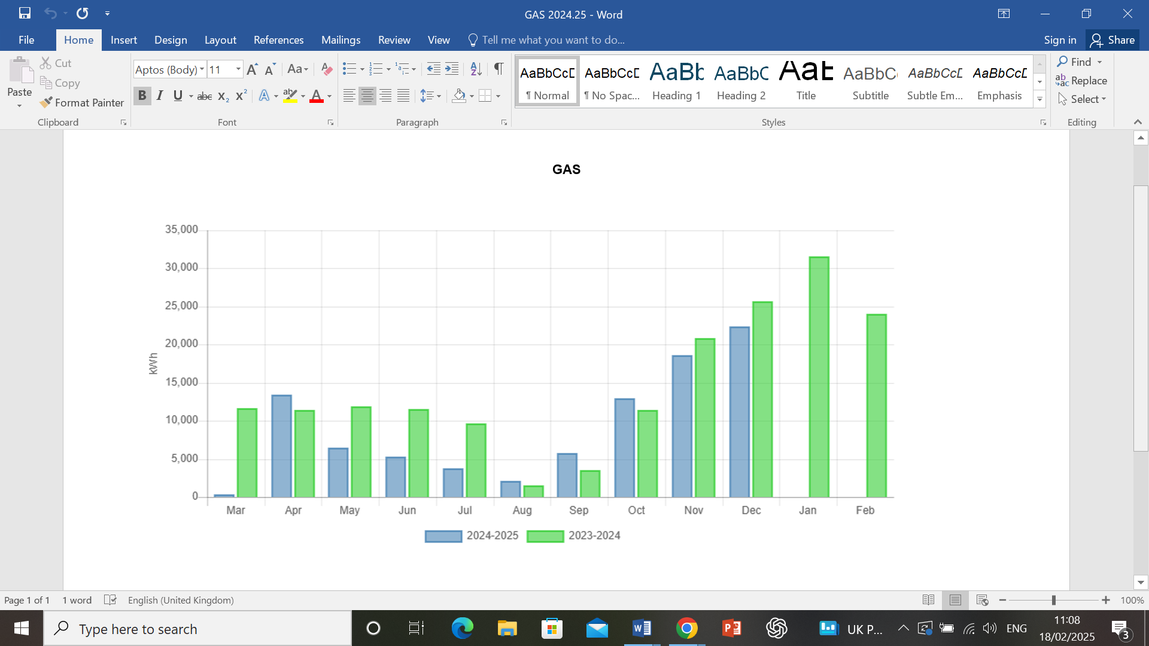

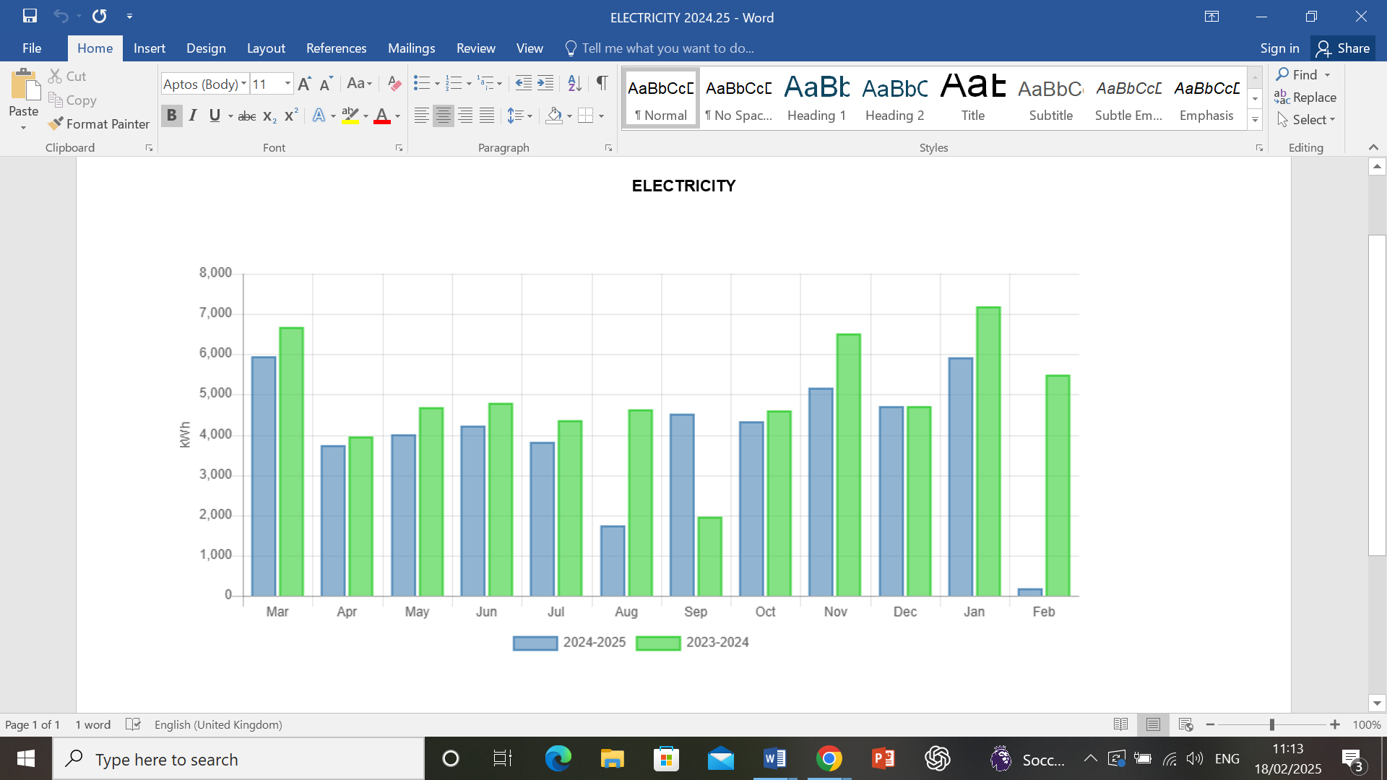

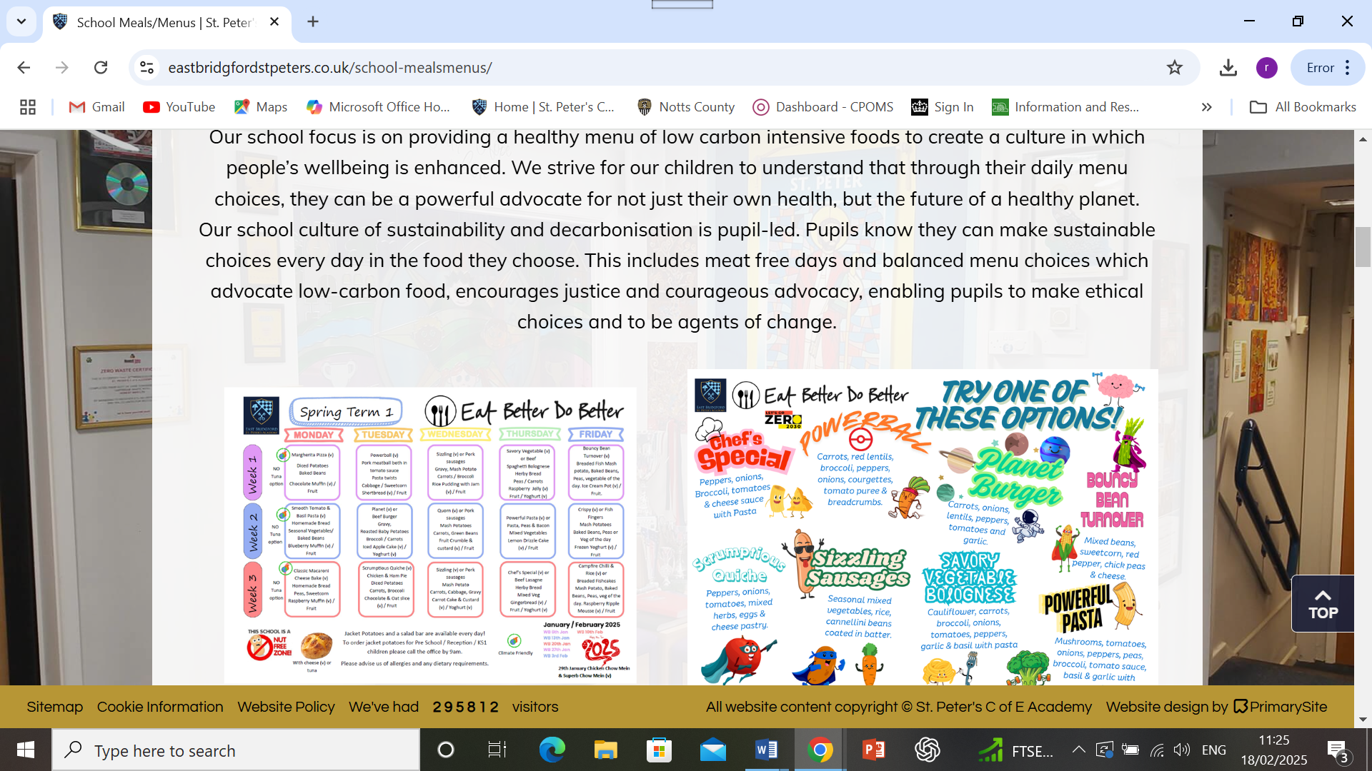

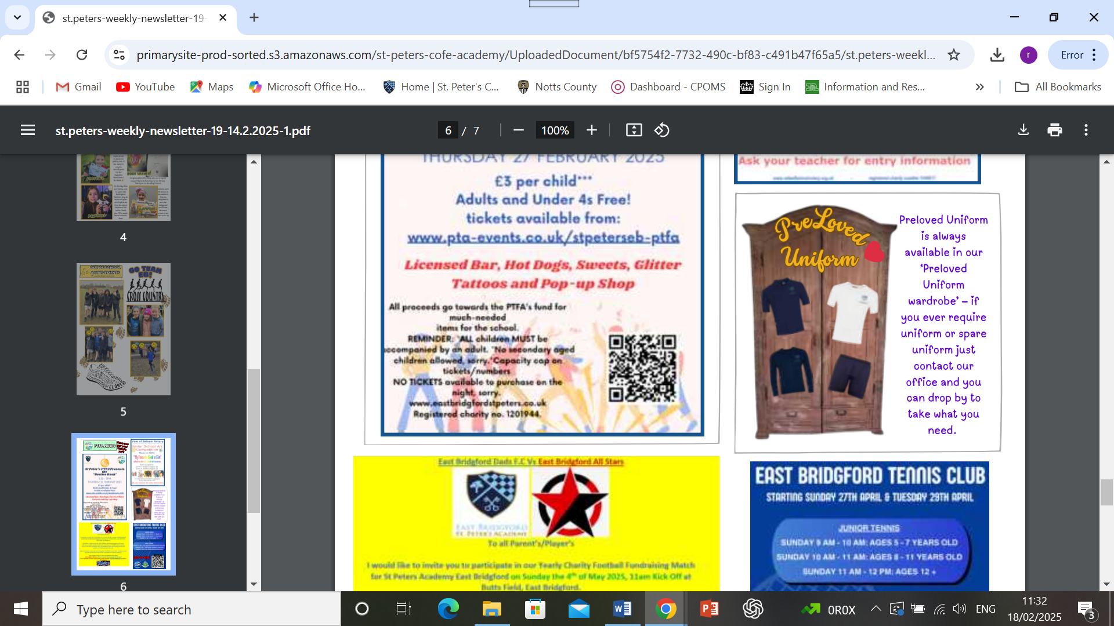

**Examples of sustainability in curriculum plans**

**KS1**

**Cycle A**

* Weather – extreme weather (climate change)
* Urban/Rural areas – population and pollution
* How material are made and where they come from – locally sourced
* Meat (link to animals)/Veg – healthy diet and seasons
* Hot and cold places
* Oceans – pollution
* Road safety – walking/public transport (competition)
* Water wastage/electricity usage
* Litter collection – homework project

**Cycle B**

* Habitats – how they are affected by humans
* Explorers – transport
* Plants – effects
* Coastal erosion – with climate change

**LSK2**

**Cycle A**

* Those late Neolithic hunter-gatherers impacted on the environment – Debates: Is hunting acceptable? Should be able to hunt animals and remove animals from their habitats?
* Bronze Age religion, technology and travel eg Stonehenge
* Iron Age hill forts: tribal kingdoms farming and its environmental impact on art and culture
* Changes in the way we travel, the food we eat, and the energy used in the last few decades and the impact of this upon our climate
* How to reduce the energy we use – Light monitors and board monitors in class
* Reflect on the food we consume and the impact of this has upon our environment – Vegetarian options discussed at the start of the day
* Recycling – Links to Stig of the Dump and The Wombles, studied during Through the Ages topic. Things that we recycle and what do we use in our house that is recycled? Links to schools preloved uniform
* Healthy eating, sustainable foods and growing food
* Carbon footprint, the weather and environment
* Fossil fuels, renewable and non-renewable energy resources – Artwork revolving around fossils and the world beneath our feet and the importance of not doing up and using fossil fuels
* Climate change, more frequent natural disasters – tsunamis and volcanoes
* Function of a plant – The importance of taking care of plants for food; growing seasonal fruit and vegetables and eating locally grown products
* Understanding and taking care of the environment
* Climate change linked to the sun
* Solar power, reducing energy
* Impact of natural disasters on habitats

**Cycle B**

* Changing habitats and the impact of change on habitats – Save our planet posters relating to how climate change is impacting habitats for orangutans in the forest and penguins in Antarctica. Ways to mitigate against this.
* Ecosystems and food chains – Made food chains and discussed how the changing habitats can impact food chains
* The tropics of Cancer and Capricorn and contrasting climates – Looking at maps and comparing climates
* Keeping food fresh, healthy foods and recyclable packaging – Looked at packages from home and what was recyclable and where food came from
* Electricity - making and fixing circuits
* Non-renewable and renewable energy sources; the impact of non-renewable energy on reducing CO2 emissions – Understanding the different types of energy and solar panels/wind turbines can save on energy
* Making switches and understanding plugs
* Cost of electricity – Site Manager to discuss how much the school spends on electricity and what uses the most electricity in school
* Civilisation – Food and farming
* The changes of farming over time
* Pollution in rivers – River observations and the impact of river life
* Land use and the effect of climate change such as flooding – Local study of river flooding and land use
* Habitats – rivers and mountains

**UKS2**

**Cycle A**

* Food ‘take care’ homework – make a seasonal dish using locally sourced ingredients (design, make, share, evaluate); Talk also from Sarah Plumb about local produce

RE

* Inspirational people – focus on climate activists

Geography

* Looking at how weather and climate change can affect climate zones, biomes and vegetation belts
* World cities with focus on population and population – debate
* Land use in the UK – case studies on farming around the world (link to IT databases)

MFL (Spanish)

* Climate in Spain and weather forecasts

History

* ‘Dig for Victory’ – emphasis on growing own produce

Debate Club

* ‘Should children be rewarded for sustainable practices in school?’

Pupil Parliament

* Pre-owned uniform swap

Class responsibility roles

* Eco monitors, energy savers, tap dripping monitors etc

**Cycle B**

Geography

* Antarctic explorer talk to KS2 touching on real life experiences of plastic sea waste; understanding of Polar regions and effect of climate change on these areas
* Natural resources – fish, oil and gas, metals and minerals, wood, freshwater (hydropower)
* Natural resource management
* Trade round the world
* Extreme weather and how linked to climate change

Art

* Ocean environmental art – exploring environmental artists and creating own art from waste

Science

* Animal adaptations – How and why

DT

* Whole food – Understanding diet and how eating red meat can effect climate change; processed versus whole foods

DT (History)

* Make do and mend project – Learning about this during war time and creating own pieces from old clothing

Cycle B, LKS2

* Changing habitats and the impact of climate change on habitats.
* Save our planet posters relating to how climate change is impacting habitats for orangutans in the forest and penguins in Antarctica. Ways to mitigate against this.
* Ecosystems and food chains.
* Made food chains and discussed how the changing of habitats can impact food chains.
* The tropics of Cancer and Capricorn and contrasting climates.
* Looking at maps and comparing climates.
* Keeping food fresh, healthy foods and recyclable packaging.
* Looked at packaging from home and what was recyclable and where food came from.
* Electricity – making and fixing circuits.
* Non renewable and renewable energy sources – the impact of non-renewable energy on reducing CO2 emissions.
* Understanding the different types of energy and solar panels / wind turbines can save on energy.
* Making switches and understanding plugs.
* Cost of electricity. Site manager to discuss how much the school spends on electricity and what uses the most electricity in school.
* Civilisation - Food and farming.
* The changes of farming over time.
* Pollution in rivers
* River observations and the impact of river life.
* Land use and the effect of climate change such as flooding.
* Local study of river flooding and land use.
* Habitats - rivers and mountains.

Cycle A, LKS2

* Those late Neolithic hunter-gatherers impacted on the environment
* Debates: Is hunting acceptable? Should we be able to hunt animals and remove animals from their habitats?
* Bronze Age religion, technology and travel, for example, Stonehenge
* Iron Age hill forts: tribal kingdoms farming and its environmental impact art and culture.
* Changes in the way we travel, the food we eat, and the energy have used in the last few decades and the impact of this upon our climate.
* How to reduce the energy we use.
* Light monitors and board monitors in class.
* Reflect on the food we consume and the impact of this has upon our environment.
* Vegetarian options discussed at the start of the day.
* Recycling
* Links to Stig of the Dump and The Wombles, studied during Through the Ages topic. Things that we recycle and what do we use in our house that is recycled? Link to schools second hand uniform.
* Healthy eating, sustainable foods and growing food.
* Carbon footprint, the weather and environment.
* Fossil fuels, renewable and non-renewable energy resources.
* Artwork revolving around fossils and the world beneath our feet and the importance of not doing up and using fossil fuels.
* Climate change more frequent natural disasters –tsunamis and volcanoes.
* Function of a plant.
* The importance of taking care of plants for food. Growing seasonal vegetables and seasonal fruits and eating local grown products.
* Understanding and taking care of the environment.
* Climate change linked to the sun
* Solar power, reducing energy.
* Impact of natural disasters on habitats.