St. Peter’s Academy – Miss. Brownley’s Year 1 Weekly Newsletter

Teacher: Miss Brownley.  TP: Mrs Peach & Mrs Wale. | Homework Subject:  Phonics - ‘i’ sound game | Date: 05.05.17

This Week:
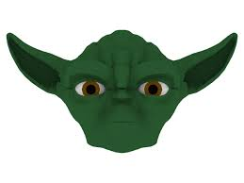
What a crazy day! Star Wars day was a huge success and thank you to all those children who took part. We had some fantastic outfits and a great effort was made by all. Please see the website for pictures from the day and, as always – may the force be with you!

Our Fairy Tale topic has moved into looking at settings and alternative stories this week. So we read an alternative version of Snow White set in 1920s New York! In this version the seven dwarves are seven jazz men, who take Snow White under their wing and hire her as their singer. The children loved comparing and contrasting the two versions. We created our own alternative settings and dwarf characters too, such as Snow White in Space where the dwarves were astronauts and Snow White under the sea where the dwarves were seahorses! Thank you for sending in a great selection of toys from the past too. We did a carousel activity where the children moved round each toy and got the chance to discuss it. Also this week on Wednesday we visited Year 3 where they showcased their Egyptian work in an Egyptian Museum. The children interacted really well with this and asked some insightful questions.

Thank you if you attended the Parent’s Meeting about the Phonics Check. I have put the slides from this on the website and there are some leaflets attached to our Year 1 noticeboard that were given out at the meeting, should you wish to take one. They are quite handy if you think your child is struggling in a particular area. Please keep checking the website for games and activities related to Phonics to support your child.

Homework: Phonics
Instructions: Each player needs a counter (children can play on their own or with as many people as they like, I could only fit 4 on the sheet!) All begin on START and roll a dice (grab the counters and dice from a game you have at home, or you could use different coins/ download online dice apps). Move forward the number you rolled and either say what the word is (if it is a picture) or say and write down a word containing the sound in your box on the grid. Play until you have filled your column on the grid.
Hopefully they enjoy this and can identify the correct ‘i’ sound for the words they think of! Please return on 12th May 2017.
Wilford’s Diary:
“Thank you for your hospitality, Leo S” said Wilford.
This week Wilford is going home with Henry.
He will return back to school on Fri 5th May and will go home with Harry B.

Weekly and General Reminders:
PE is on Tuesdays and Thursdays (both will now be outdoor, weather permitting)
Books changed on a Wednesday (please ensure your child brings their books and diary to school every day as we vary the days they read to us)
IF YOUR CHILD HAS LONG HAIR PLEASE CAN YOU ENSURE THAT IT IS TIED BACK FOR PE OR THEY HAVE A BOBBLE THAT THEY ARE ABLE TO USE.
**INSET DAYS – FRI 26TH MAY AND FRI 30TH JUNE 2017**
Homework due in – Phonics Game / Fri 12th May 2017

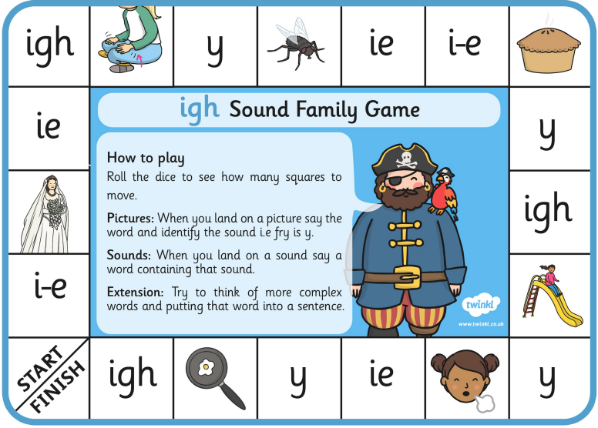

Player 1  NAME_______________ | Player 2  NAME_______________ | Player 3  NAME_______________ | Player 4  NAME_______________

