St. Peter’s Academy – Miss. Brownley’s Year 1 Weekly Newsletter

Teacher: Miss Brownley.  TP: Mrs Peach & Mrs Wale. | Homework Subject:  Split Digraph Mosaic | Date: 19.05.17

This Week:

Happy Friday everyone! A quiet week at school this week (for once – I wasn’t sure that could exist at St. Peters!) as we have had no Year 6’s and then near the end of the week no Year 2’, as they have been on their residential trips.

In Literacy we have finished our Fairy Tale topic and have begun looking at letter writing. At the beginning of the week to get us familiar with how a letter is set out we wrote a letter to guests inviting them to Mr. Maddison’s leaving party (purely fictitious!) and then on Wednesday and Thursday we focused on a lovely book called ‘Dear Greenpeace’, which shows a girl called Emily’s letters to Greenpeace about a whale living in her pond and their replies. If you wanted to have a look at this at home I have put an e-book link on the website, the children have really enjoyed it and are interested in learning more about Greenpeace next week. In Numeracy we have been dividing all week, in 2s, 5s and 10s, both practically, in number sentences and worded problems. In Science we studied how trees change throughout the four seasons and why.

Homework: Phonics
Please see reverse for this week’s Phonics homework. Due Thursday 25th May.
There won’t be any set next week for over half term, enjoy! ☺
Wilford’s Diary:
“Thank you for your hospitality, Henry” said Wilford.
This week Wilford is going home with Eddie.
He will return back to school on Thurs 25th May to go home with Darcy for half term ☺.

We are in the final few weeks of Wilford’s Diary now and his remaining visits are:
9/6/17 Rose 16/6/17 Frederick 23/6/27 Joshua P 30/6/17 Hallie 7/7/17 Isaac

Weekly and General Reminders:
PE is on Tuesdays and Thursdays (both will now be outdoor, weather permitting) *Due to the building work, if the weather is rainy/wet, we will be unable to use the hall instead of the field. This is due to the hall now becoming an interchangeable classroom. We are hoping this will not be too much of a problem but please bear with us at this time. Where possible we will try to do teambuilding activities in the classroom when we can’t do PE.
Books changed on a Wednesday (please ensure your child brings their books and diary to school every day as we vary the days they read to us)

DATES TO NOTE:
26th May INSET 12th-15th June Phonics Check Administered 30th June INSET
5th July Sports Day-KS1 afternoon 7th July PTA BBQ 18th/19th/20th KS2 Production Days
Final day of term Tuesday 25th July 2017
Homework due in – Split Digraph Mosaic – Due 25/5/17
(There will be no homework set over half term!)

Name……………………………………………………… Due: Thursday 25/5/17

Split Digraph Phonics Mosaic
*Parent Help: What is a split digraph? A digraph is two letters (two vowels or two consonants or a vowel and a consonant) which together make one sound (as in the words tail, boat, found or read). When a digraph is split by a consonant it becomes a split digraph. For example: wrote – the 'o-e' here make one sound.

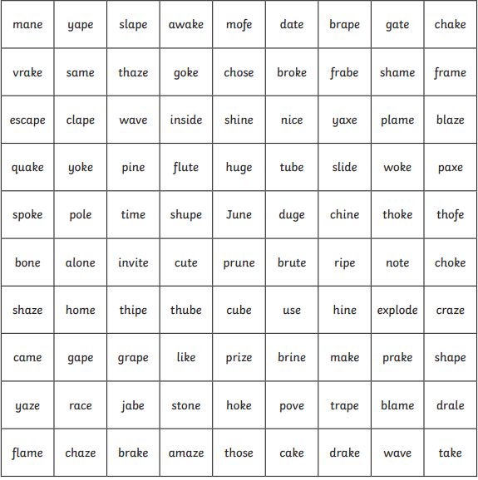
Instructions – Read the real and alien words. Use the key to colour in the squares to show the hidden picture.

KEY: ‘a-e’ split digraph blue
‘i-e’ split digraph yellow
‘o-e’ split digraph red
‘u-e’ split digraph purple

