St. Peter’s Academy – Miss. Brownley’s Year 1 Weekly Newsletter
Teacher: Miss Brownley.  TP: Mrs Peach & Mrs Wale. | Homework Subject:  Ongoing – Mad About Ducks! | Date: 3.2.17

This Week:
Short and sweet this week as we prepare for our final week in school. Our second bird watch was very successful, we saw magpies, crows, blackbirds, chaffinches, sparrows, blue tits and pigeons. The children learned about the different types of behaviours that the birds display and about the varying food they eat.

Dates to remember for next week:
Thursday 9th Feb – Stroke Awareness Campaign Day (non-uniform) – see letter from Mr Maddison.
Friday 10th Feb – INSET Day (staff training, children not in school).
Monday 13th Feb – Half term week
Monday 20th Feb – return to school and ducklings delivery this week.
Homework: Mad about ducks! Please see previous newsletter sent home (and online).
Wilford’s Diary:“Thank you for your hospitality between this week Helena” said Wilford.
This week Wilford is going home with Leo H.
He will return back to school on Thursday 9th Feb and will go home with Harry S for the holiday.
Weekly Reminders: As normal in the final week
*PE Tuesday and Thursday (indoor kit for both)* and *Book changing on Wednesday*
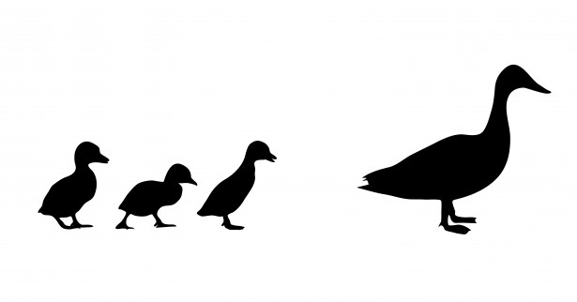

St. Peter’s Academy – Miss. Brownley’s Year 1 Weekly Newsletter
Teacher: Miss Brownley.  TP: Mrs Peach & Mrs Wale. | Homework Subject:  Ongoing – Mad About Ducks! | Date: 3.2.17

This Week:
Short and sweet this week as we prepare for our final week in school. Our second bird watch was very successful, we saw magpies, crows, blackbirds, chaffinches, sparrows, blue tits and pigeons. The children learned about the different types of behaviours that the birds display and about the varying food they eat.

Dates to remember for next week:
Thursday 9th Feb – Stroke Awareness Campaign Day (non-uniform) – see letter from Mr Maddison.
Friday 10th Feb – INSET Day (staff training, children not in school).
Monday 13th Feb – Half term week
Monday 20th Feb – return to school and ducklings delivery this week.
Homework: Mad about ducks! Please see previous newsletter sent home (and online).
Wilford’s Diary:“Thank you for your hospitality between this week Helena” said Wilford.
This week Wilford is going home with Leo H.
He will return back to school on Thursday 9th Feb and will go home with Harry S for the holiday.
Weekly Reminders: As normal in the final week
*PE Tuesday and Thursday (indoor kit for both)* and *Book changing on Wednesday*

