St. Peter’s Academy – Miss. Brownley’s Year 1 Weekly Newsletter
Teacher: Miss Brownley.  TP: Mrs Peach & Mrs Wale. | Homework Subject:  N/A | Date: 27.01.17

This Week: 新年快乐 Happy Chinese New Year!

We’ve been to East Bridgford Hill today to take part in their Chinese New Year celebrations and hopefully some of you will be able to join them after school for a spring roll and a story! We’ve sampled Chinese tea, listened to a traditional tale and looked at the beautiful school work we’ve created that has been displayed around the house. We really enjoyed the celebrations ☺

At the beginning of the week we went outside in the playground to hang our birdfeeders in the tree with Mr Maynard (check out the school Twitter page to see us in action). However, when we got outside we discovered that Mr Maynard’s ladder was just a bit too short to reach the branches, so we’ve hung the birdfeeders on the fence underneath the tree instead. There are also a few in the hedge to encourage the birds ‘who may be a bit shy’ (the children’s words not mine - very thoughtful!) On Thursday the children were lucky enough to be taught by Miss Fisher for the morning as Miss Brownley was out on a course, so they put their bird spotting skills to the test and went on a brief walk around the school grounds on an ornithology expedition looking for birds in our local environment. We will be going on a second ornithology expedition on Wednesday afternoon (weather dependent!). We’re hoping to do a comparison of birds we see in the morning against birds we see in the afternoon. For this we will be strolling further afield and venturing around the school grounds and the field, so in case it’s muddy you may wish to provide your children with wellies/old footwear for this. Additionally, if children have access and permission from you they are more than welcome to bring in binoculars they may have at home to use on our bird-watching walk.
Homework: Mad about ducks!
As we are having some cute new arrivals in Year 1 we would like the children to be as prepared as possible for their stay. For this, we would like the children to do a little bit of background research into ducks and present this in a ‘take care’ way. Our aim is to get the children really excited about looking after the ducks and this homework will be the beginning of that. Please don’t panic, it doesn’t have to be a complicated piece of homework and feel free to be as abstract as possible! Some ideas are below:
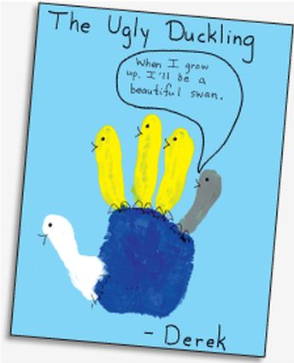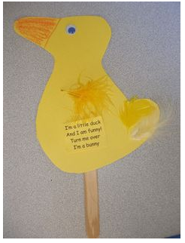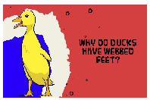
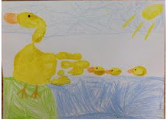

-Duck poetry (reproduced in a ‘take care’ way or create their own)
-Write a story to include ducks/reproduce their favourite part in a duck story (lots of potential for borrowing books from the library such as Dr Seuss - I wish I had duck feet, The Ugly Duckling tale, Eric Carle – Ten Little Rubber Ducks for some starter ideas, lots of others online)
-Create a piece of duck craft (lots of ideas on sites such as Pinterest)
-Research different duck types/one specific type of duck and present findings in a ‘take care’ way
-Research why ducks waddle/ why they have webbed feet/ what their environment is like and present findings in a ‘take care’ way
-Create a ‘care guide’ for how to look after a duckling/duck.
*What we would ask is that these be no bigger than A3 paper size – this is due to the size of our display area and the amount of children in our class.*
These will be collected in after half term – Monday 20th February

Wilford’s Diary:
“Thank you for your hospitality between this week Jess” said Wilford.

This week Wilford is going home with Helena.
He will return back to school on Friday 3rd February and will go home with Leo H.
Weekly Reminders:
Bring in binoculars (with permission from an adult) on Wednesday and a change in footwear in case it is muddy on the field (wellies/old footwear).
*PE Tuesday and Thursday (indoor kit for both)* and *Book changing on Wednesday*

Homework due in: ‘Mad about ducks’ project due in Monday 20th February 2017.

