**Sammy’s super sporting quiz**

1. When did England win the football World Cup?
2. Who won the last Premier League title?
3. Which teams plays at the Etihad Stadium?
4. What length is an Olympic size swimming pool?
5. Who is the fastest man in the world over 100m?
6. Which country has won the most Olympic medals?
7. Who won the last cricket world cup?
8. In rugby union, how many points do you get for a try? For a bonus point how many points do you get for a conversion?
9. How does a hockey match start?
10. What is the name of the Nottinghamshire cricket T20 team?
11. Name 3 sports where you use a board?
12. What is it called when you knock all the pins down in one at Tenpin Bowling?

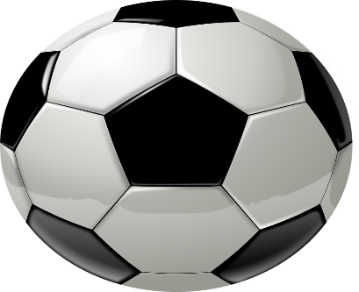

[This Photo](https://quantixed.org/2018/06/27/pentagrammarspin-why-twelve-pentagons/football-157931_960_720/) by Unknown Author is licensed under [CC BY](https://creativecommons.org/licenses/by/3.0/)

**Sammy’s super sporting quiz answer sheet**

1. 1966
2. Liverpool
3. Manchester City
4. 50 metres
5. Usain Bolt
6. USA
7. England
8. 5 + Bonus point = 2
9. Push back
10. Notts Outlaws
11. Surfing, Snowboarding, Skateboarding, wakeboarding, windsurfing, paddle boarding, kiteboarding
12. Strike

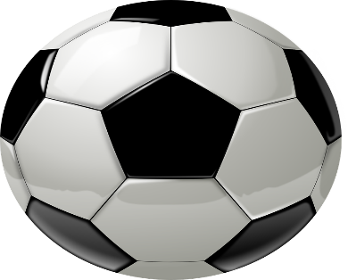

[This Photo](https://quantixed.org/2018/06/27/pentagrammarspin-why-twelve-pentagons/football-157931_960_720/) by Unknown Author is licensed under [CC BY](https://creativecommons.org/licenses/by/3.0/)