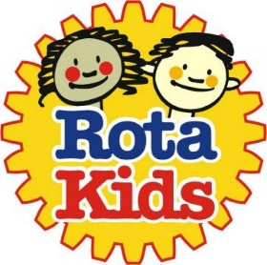
Vision - "Taking care of our community and our world"
- To make an environmental difference to our school, community and globally.
- To leave a legacy of good environmental energy saving habits. We will strive to achieve this by: a shock, inform and persuade approach so others will think carefully about the environment.
- To put a smile on people’s faces.

How will we know we have been successful:
- Our energy bills will be reduced.
- The whole school will be able to talk about their energy saving habits at school and at home.
- Children and adults will be able to articulate about global climate change and how they can make a difference.

- Turn off lights when not in the room.
- Consider natural light or only having on certain lights.
- Do you have to have the clever touchscreen on all the time? Use a flipchart and pens.
- Put your laptop screen down to save energy.
- Use recycled paper for a scrap paper tray.
- Where possible print only in mono, save colour ink for essential work.
- Have outside lessons when appropriate.
- Check radiator settings and windows for a comfortable working thermal classroom environment.
- Work smarter. Have essential items ready so not to waste class resources.
- Only take water you need.

Thank you. Signed Rotakids

