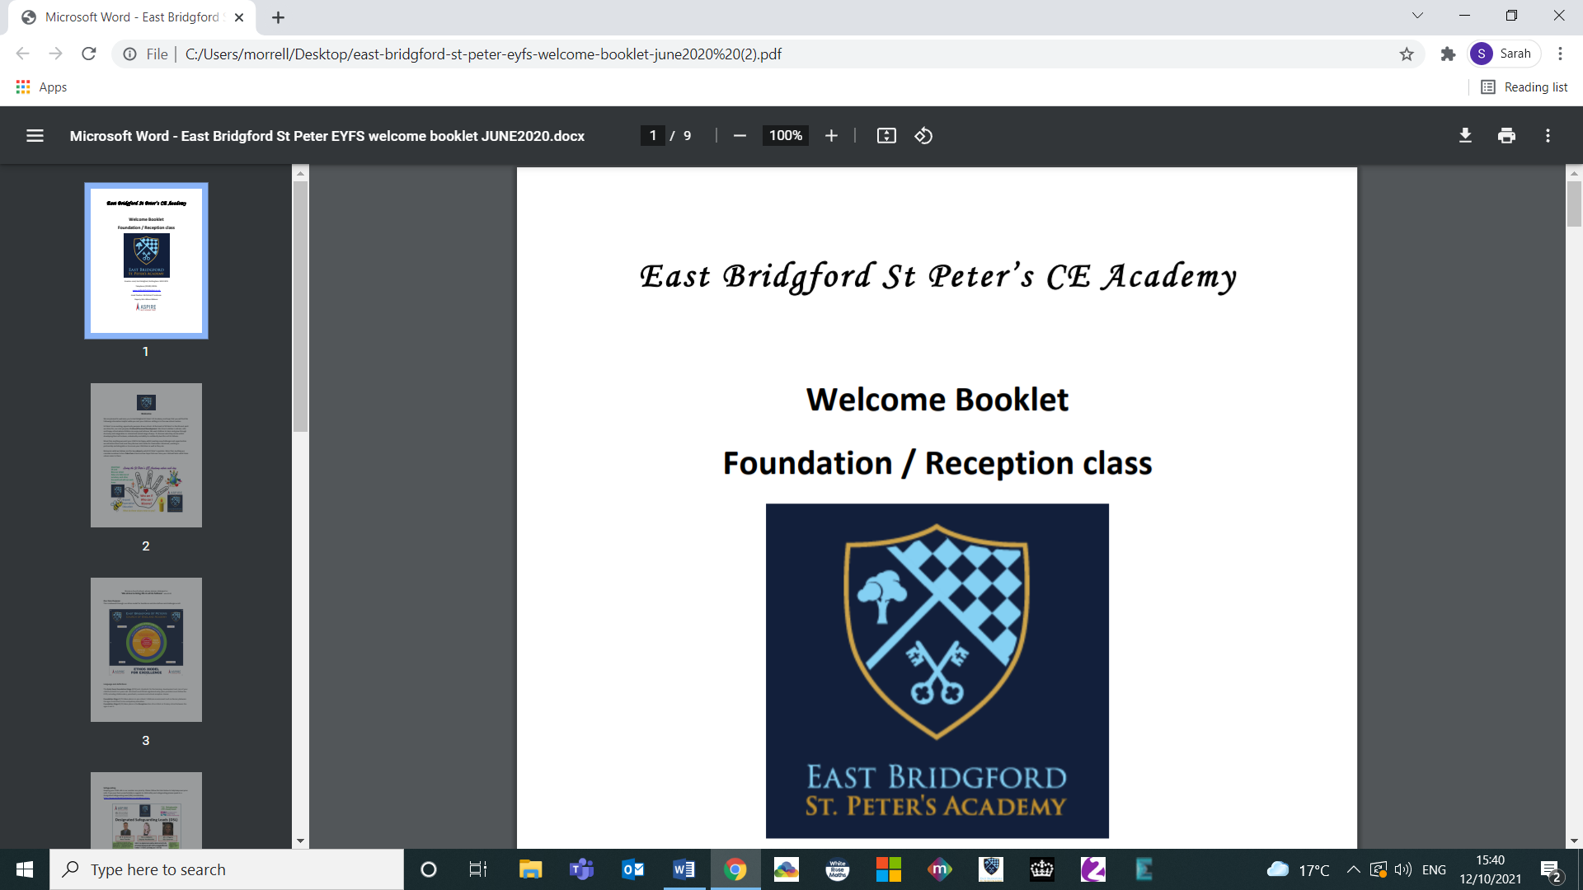

All About Me

East Bridgford

St Peter’s Nursery

Insert photo

My Name is

………………

Jul 2021

The purpose of this booklet is for us to find out more about your child, their likes, dislikes and how they are learning and developing. This will help us to identify what we can then do to support your child during their time at our nursery

Preschool Experiences

* Playgroup/Preschool
* Day nursery
* Nursery class
* Home
* Childminders home

What is the name of any other settings attended?

.................................................................................................................................................................

Any additional needs i.e. physical, SEN, speech and language, separation anxiety or information you feel we need to know.

.................................................................................................................................................................

.................................................................................................................................................................

.................................................................................................................................................................

.................................................................................................................................................................

Who lives in my house:

.................................................................................................................................................................

My favourite toys are:

.................................................................................................................................................................

I like going to:

.................................................................................................................................................................

Any other information you might need to know about me to help me settle:

.................................................................................................................................................................

If I’m sad or upset you can help me by:

.................................................................................................................................................................

I might be anxious/upset if:

.................................................................................................................................................................

I don’t like:

.................................................................................................................................................................

I feed myself with:

.................................................................................................................................................................

I drink out of a:

.................................................................................................................................................................

Food I like:

.................................................................................................................................................................

Food I don’t like:

.................................................................................................................................................................

Toileting (independent, nappies, pull ups or where I may need help):

.................................................................................................................................................................

(Please read the statements and then tick any which represent your child.)

Personal, Social and Emotional

* I am increasingly curious about my world and I want to explore it and be noticed by you.
* I know what I want to play with, what to eat, what to wear.
* I am starting to enjoy the company of other children and I want to play with them.
* I can sometimes manage to share or take turns with others, with adult guidance and understanding ‘yours’ and ‘mine’.
* I settle to some activities for a while.
* I am confident in new social situations.
* I play alongside others.
* I like to pretend play (for example, being ‘mummy’ or ‘daddy’?)
* I like to take part in other pretend play with different roles – being the Gruffalo, for example.
* I can generally negotiate solutions to conflicts during my play.
* I can remember the rules without an adult having to remind me.
* I can talk about my feelings using words like ‘happy’, ‘sad’, ‘angry’ or ‘worried’.
* I am starting to know how others are feeling.



Communication and Language

My home language is:……………………………………………………………………….

I also speak/understand:

**…………………………………………………………………………….**

* I listen and responding to a simple instruction like:“Adam, put on your shoes?”
* I can shift my attention from one task to another if you get my attention by using my name : “Jason, can you stop now? We’re tidying up”.
* I can say at least 300 clear words.
* I can say a sentence of 4-5 words.
* I use words such as me, she, he.
* I use words such as in, on, under.
* I can follow a simple instruction e.g. “Can you wash Dolly’s face”
* I can understand action words “Who is jumping?” by pointing to the picture in a book.
* I can use sentences of 4 to 6 words – “I want to play with cars” or “What’s that thing called?”
* I can use sentences joined up with words like ‘because’, ‘or’, ‘and’? For example: “I like ice cream because it makes my tongue shiver”.
* I talk using the future and past tense: “I am going to the park” and “I went to the shop”?
* I can answer simple ‘why’ questions.

Physical

* I can run well.
* I can kick a ball.
* I can jump with both feet off the ground at the same time.
* I can climb confidently.
* I can catch a large ball.
* I can pedal a tricycle.
* I can go up and down stairs using alternate feet.
* I can stand on one leg.
* I can hop.
* I can skip.
* I can make little snips in paper using scissors.
* I know how to hold a knife and fork.
* I can put on my own coat.
* I can start and pull up the zip on my coat.
* I can pull up my own pants and trousers.
* I can wash and dry my own hands.

When holding pencils, paint brushes and scissors I use my

* **Left hand**
* **Right hand**
* **Both**

Literacy

* I join in with some words and actions at song time.
* I repeat words and phrases from my favourite stories.
* I notice things like my name, a bus or door number or a familiar logo.
* I like to draw and paint.
* I sometimes tell you what my pictures/marks are when you ask e.g. “That says mummy”.
* I know how to hold books, carefully, the right way up and I can turn the pages one at a time.
* I know books have a cover, page numbers, title, and stories have a start, middle and end.
* I can hear it when words rhyme.
* I like to talk a lot about my favourite stories.
* I can write some letters of my name.

My favourite rhymes and stories are:

……………………………………………………………………………….

 

Mathematics

* I can use language such as little, big, heavy, high, low, smaller.
* I can count to 5 but I might skip a number such as 1,2,3,5.
* I can compare amounts saying “lots”, “more” or the “same”.
* I notice patterns such as animals with spots or stripes.
* I can recognise a group of 3 items without counting each item.
* I can count past 5.
* I can count and point to each item as I say the number name.
* I can show “finger numbers” up to 5.
* I know how many there are – “1,2,3…..there are 3 cars”
* I can talk about position without pointing such as “The bag is **under** the table”, “**on** the table”, “**in front** of the box” “**in** the box” “**behind** the wall”.
* 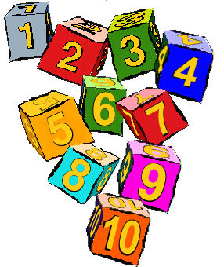I can talk about circles, squares, rectangles and triangles using words such as sides, corners, round.

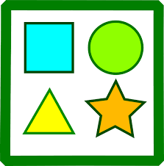

Understanding the World

* I notice differences between people such as you are a girl, I am a boy, you have red hair, I have black hair.
* I enjoy exploring the natural world including splashing in puddles, looking for worms and mini-beasts, growing plants.
* I can talk about what I see in the world around me such as different shells, leaves, the weather
* I like to tell you about members of my family and remember what things we do together.
* I am interested in different occupations such as doctors, police officer, teachers.
* I like to explore and think about such things as melting, shadows, sinking and floating, cooking.
* I enjoy playing with magnets, stretching elastic bands and feeling the forces at work.
* I notice similarities as well as differences between us.



Expressive Arts & Design

* I join in with songs and rhymes, making some sounds.
* I explore a range of sound-makers and instruments and play them in different ways.
* I explore paint, using my fingers and other parts of my body as well as brushes and other tools.
* I pretend play, pretending that one object represents another such as a wooden block is a mobile phone.
* I like to use different materials such as playdough, fabrics, tubes, cardboard boxes.
* I like to take part in simple pretend play, which now sometimes have “rules”.
* I am beginning to develop more complex stories using small world equipment like animal sets, dolls and dolls houses.
* I can use construction sets and blocks to make my own small world like towns, different buildings.
* I can draw a picture of a face using a circle and then add the eyes, nose and mouth.
* I like to make new colours by mixing primary coloured paints.
* I can remember and sing a couple of songs

