St. Peter’s Academy – Fortnightly Newsletter
Miss Brownley’s Class (3/4) | Date: Friday 10th November 2023
Messages:
Welcome back! I hope you and the children had a lovely break, they’ve definitely returned raring to go and counting down until Christmas (already!) Thank you for those who have sent back the parent’s evening forms – please get these in as speedily as you can as slots get booked up quickly. They will be held on Tues 21st and Weds 22nd November.

Homework this week is listed below: Link to Purple Mash here.
Reading – 3 x per week and recorded in their diary planner – this can be independent or with an adult.
SPaG – Spelling week – Spellings label in diary planner.
Times Tables – Set on Purple Mash as a 2Do.
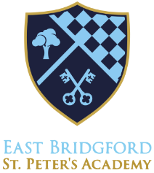
English – For homework over the next 2 weeks, we are challenging the children to write a 100 word story! Today, they have taken home a Crazy Creatures story activity pack. In this pack the children will generate ideas which will lead to them writing a 100 word mini saga inspired by their creature. We will then enter each story into the Crazy Creatures creative writing competition for 7-12year olds and prizes for the best entries include; the children’s story being published in a book, a Young Writer’s Award of Excellence, a £100 National Book Token (for the school), a creative writing goody bag and every entrant will receive a bookmark and a sticker for their effort. We can’t wait to see what ideas the children create!

