**App’s to Support Spelling**

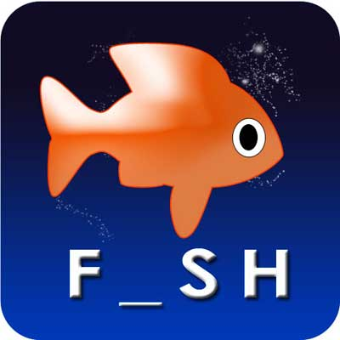**Word Magic**

[Word Magic](https://play.google.com/store/apps/details?id=com.anusen.wordmagic) is a spelling app for the iPad and Android devices that helps students to learn basic spelling skills.  The app presents children with a picture that has letters missing from its description which the student must guess.  There are also several different levels of difficulty designed to strengthen spelling skills which include words that are missing one letter or multiple letters.

Students are also presented with words that are different lengths and words with upper or lower case letters.  As the level of difficulty increases, the app keeps score of the number of words spelt correctly.  Students continue to receive positive reinforcement throughout the game via awards, sound effects, and prizes.

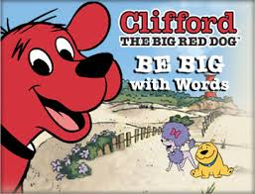**Clifford’s BE BIG with Words**

[Clifford’s BE BIG with Words](https://www.commonsensemedia.org/app-reviews/cliffords-be-big-with-words) is a spelling app for the iPad and iPhone that helps young students practice spelling three letter words correctly.  The app is designed to guide students in spelling three letter words from a selection of letters they can choose from.  Once the word is spelt correctly, a voice reads the word out loud to help the student learn how to pronounce it.

In addition to word pronunciation, students can learn to distinguish between words, sounds, and word spellings.  This portion of the app increases student awareness of sounds and how they relate to spelt words.

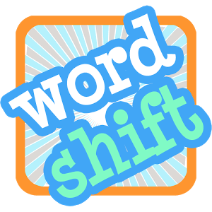

**Word Shift**

Word Shift is an app for Android devices that engages young students in a word puzzle game. The game is set up with misplaced letters in commonly used words and students tap on the letter to move it to the correct location within the word.  Students are given one chance to spell the word correctly to help improve attention skills. Plus, the app is designed for multiple players to enhance motivation.

When the game is complete, students can view their progress on the number of words they spelt correctly and the number that were incorrect.  Additionally, if students find a word that is difficult, the app will display hints at the bottom of the screen.  By encouraging students to correct misspelt words, the [Word Shift](https://play.google.com/store/apps/details?id=in.blacklight.word.shift) app helps to strengthen spelling skills.

**Pogg**

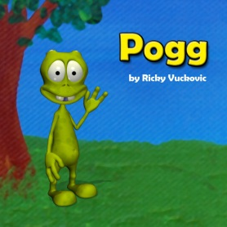Pogg is a spelling app that includes a green alien that teaches students critical spelling skills through his actions.  The alien performs a variety of activities such as eating, reading, drawing, and anything else the student instructs him to do.  The app contains two modes which are Spelling Mode and Picture Mode.

When you use the Spelling Mode, the app will ask the student “What should Pogg do now?”  When the student types a word on the virtual keyboard, Pogg will perform the task that is associated with the word.  [Pogg](https://itunes.apple.com/WebObjects/MZStore.woa/wa/viewSoftware?id=330964517&mt=8&ign-mpt=uo%3D8) keeps students engaged by letting them spell a wide variety of words to watch Pogg demonstrate the task.

Picture Mode allows students to see all of the Pogg animations displayed on the screen in the form of icons.  When an icon is touched, it demonstrates the actions associated with the icon.  For example, if the icon displays a bell, the animation will show Pogg ringing a bell. The app provides a spelling dictionary of several hundred words with animations to help students learn word and phrase combinations.

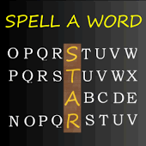**Spell a Word**

Spell a Word is an app for iOS and Android devices that helps students develop strong spelling and vocabulary skills.  The app is setup in the form of a spelling game that provides you with the initial two letters of a word selected at random.  The app provides students with clues related to the word so they can determine what the word is so they can spell it correctly.

The [Spell a Word](https://play.google.com/store/apps/details?id=com.xanosoft.android.SpellAWordGame) app allows you to set spelling challenges at a variety of different levels to encourage skill development and to accommodate those students with more advanced spelling skills.  You can also use Practice Mode to teach students how to spell words that are spoken through the app.

Additionally, there are hundreds of sounds, images, and words that you can download from the developer’s website free of charge. Spell a Word also provides a way to collect assessment data to track student skills.

All apps can be found via itunes.apple.com or Google play store go to play.google.com