
St. Peter’s Academy – Mr. Jennings’ Class Welcome Letter

UKS2 Staff:  Mrs. Marston – Teacher 5/6  Miss. Brownley – Teacher 6  Mr. Jennings – Teacher 5  Mrs. Smith UKS2 Teaching Partner | Homework:  Maths – Interpreting Timestables | Date set: 27/11/2020  Date due: 04/12/2020

This week we have started reading our class book ‘Tom’s Midnight Garden'. This book is being read to the children and then focusing work around this book and ‘Time Traveller’ topic.

This week, we have ended our block in Maths on statistics. This block focused on tables and graphs and provided many challenges for us to overcome as a class. We are now going to be moving on to look into Multiplication and Division. This will be more familiar to the class but will provide many more challenges for us to take on.

We have started to look into the 7 Stages of Life. This is essentially the timeline from young to old and allows us to use Art and creativity to draw and edit ourselves to take us back into the past or further into the future. We have done portrait sketching on the topic as well as using an online software to try and make ourselves look older than we are.
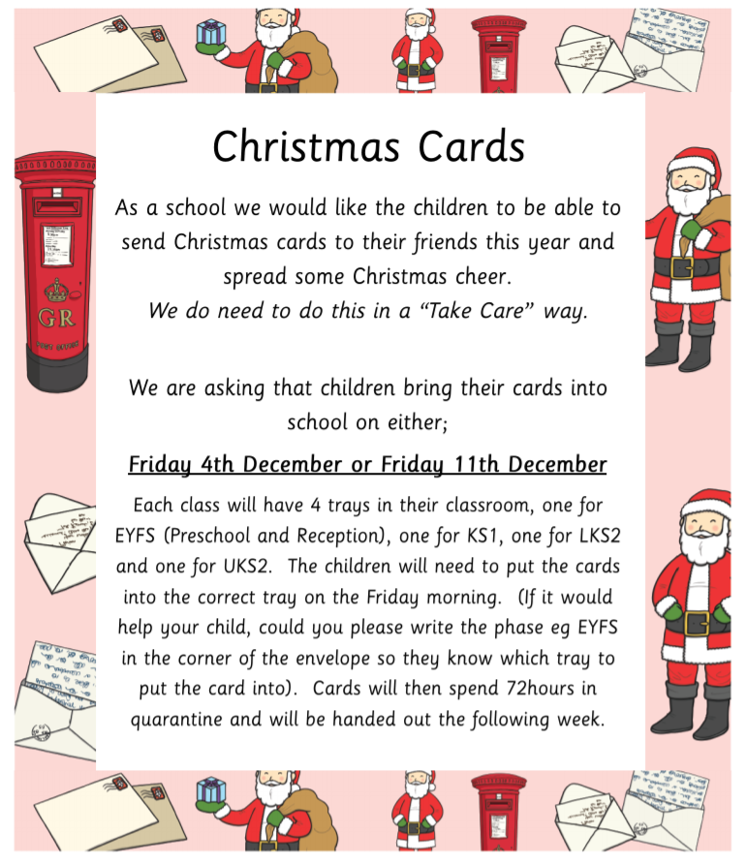

Please read the poster that has been emailed with regards to how we will be inviting the children to send Christmas cards to their friends in other bubbles this year. Additionally, Christmas dinner day for children will be on the 9th December and Christmas Jumper Day on 11th December. The children will also be performing a Christmas hymn which we will be filming and will make available for you to view on the school website (date TBC).

Thank you so much for all of your hard work for the Stargazers project. The photos are absolutely fabulous and the children have wanted to see them today. I will be showing them all of the designs next week!

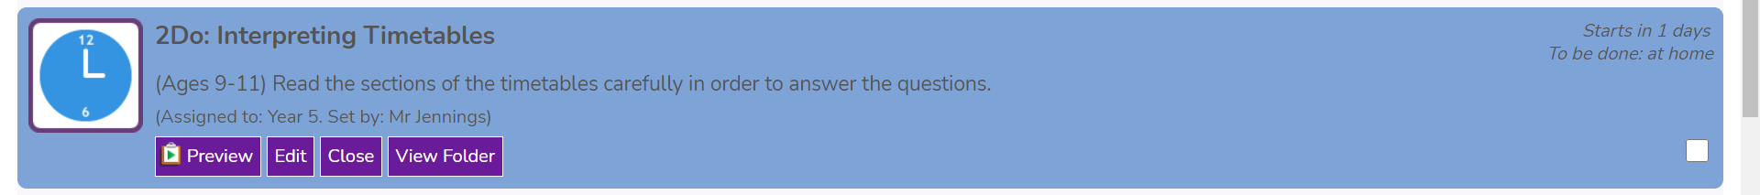
Homework
As the children have just completed a project style homework, this week we would like the children to complete the Snow Cam activity set for them on Purple Mash, answering the question and reflecting in the speech bubble: What is the meaning of Christmas? What does Christmas mean to you?

Thank you,
Have a fantastic weekend and I look forward to welcoming you back on Monday.
Mr Jennings

