
St. Peter’s Academy – Mr. Jennings’ Class Welcome Letter

UKS2 Staff:  Mrs. Marston – Teacher 5/6  Miss. Brownley – Teacher 6  Mr. Jennings – Teacher 5  Mrs. Smith UKS2 Teaching Partner | Homework:  PurpleMash  - English – Passive Voice  - Maths – Problem Solving  - Spanish – Learning games | Date set: 06/11/2020  Date due: 13/11/2020

This week we have been recapping addition and subtraction. We have been looking at how to use these operations in problem solving and how to effectively find out which operation we choose for the question at hand.

We have been looking into newspaper reports yet again and focusing on the features which you would find in a report. Ranging from Headlines to By-Lines. We will be aiming to write a report on a theme relating to Space. I hope to get these written up on Laptops and placed onto the class website.

Rev Ruth Colby, the Church and I would like the children to colour in a poppy and display in their window at home this weekend. Your child should have with them a poppy sheet with them to complete and put up ready for remembrance day. You can colour and decorate these however you like!!

Homework

This week’s homework will consist of online pieces from PurpleMash and having access to our Spanish Curriculum. To access our MFL site for your Spanish homework, you will need to access Languageangels.com.

When you reach the website, you will be asked to login to ‘Pupil Games’. The login details are below:
Username: games
Password: games.

Once you have accessed this, you will need scroll down and click ‘Numbers’. You then will have a go at the following titles:

Numbers 11 – 20 Memory.
Numbers 11 – 20 Bingo.

There are 2 ToDo’s on PurpleMash ranging from Maths to English. If you have any issues with accessing these, please let me know as soon as you can.

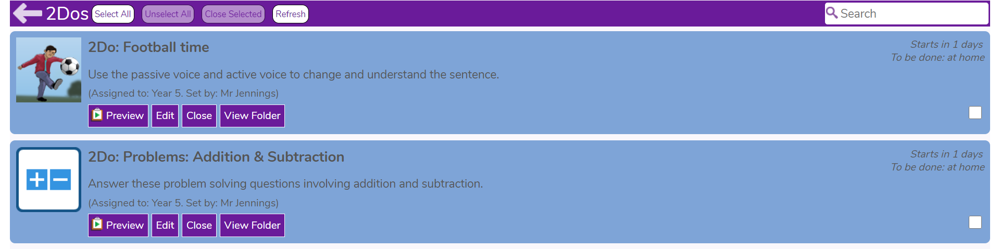

Thank you,
Have a fantastic weekend and I look forward to welcoming you back on Monday.
Mr Jennings

