Harry’s sports quiz.

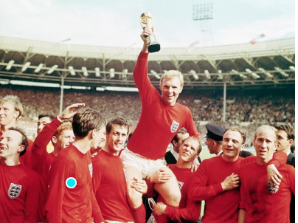

What year did England win the football world cup?

1. How many teams are in the premier league?
2. What age did Lionel Messi move Barcelona?
3. What team does Harry Kane play for?
4. Who is Tottenham new signing?
5. In which football stadium do Manchester United play all their home matches?
6. In the Olympics you get a gold medal for coming first, what do you get for coming second and third (two answers)?
7. In which country did the Olympic games originate?
8. Andy Murray is a champion in which sport?
9. What sort of snack food does former footballer Gary Lineker advertise on television?
10. What do teams pull in a game of tug of war?
11. What colour balls are worth one point in a game of snooker?
12. How many vertical wooden stumps make up a cricket wicket?
13. What do players hit in the game badminton?
14. What name is given to the spear like object thrown in athletics at the Olympics?
15. Michael Phelps has won the most Olympic medals ever; which sport did he compete in?
16. Which football team are also called The Gunners?