t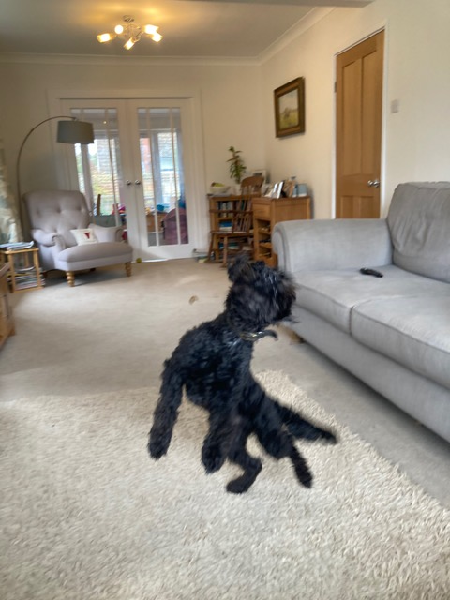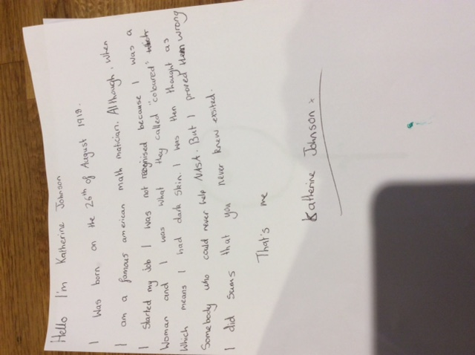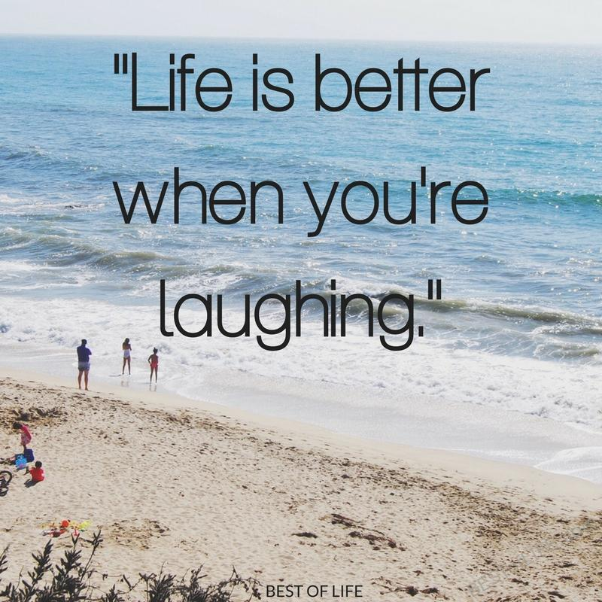

I wrote about Katherine Johnson and watched a

Film called Hidden Figures it was an interesting film and I enjoyed it.

I took some pictures of Benjy and this is one of them

By Jessica Youatt