Jessica’s Newsletter

This is what I got up to this week.

Lucy and I made flatbreads ,falafels and banana bread for lunch. This was our first time making them and it went pretty well.

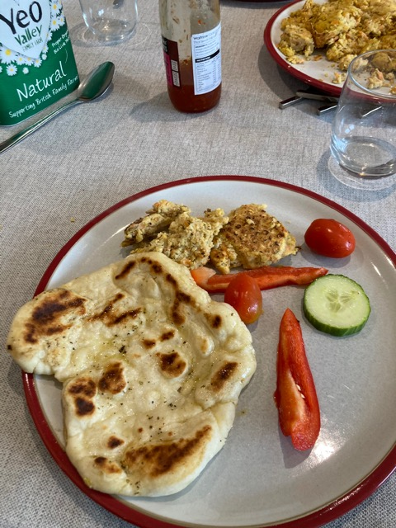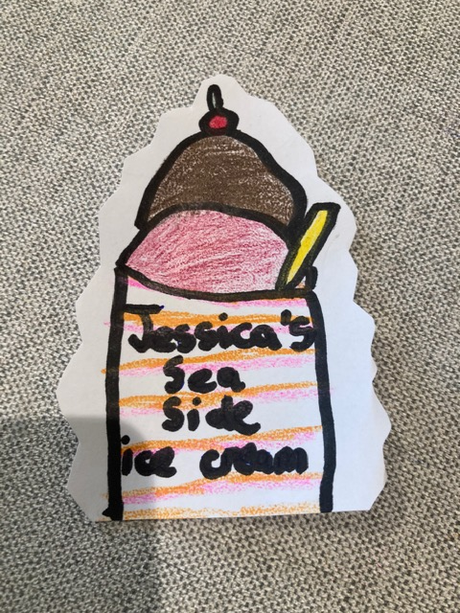

I also did some drawing and this is one of them. I got this idea from when I went to the beach and created it in my own way ICE CREAM!!!

In geography I learned about biomes on Oak Tree Academy it was fun learning about biomes and I can now tell people what they are.

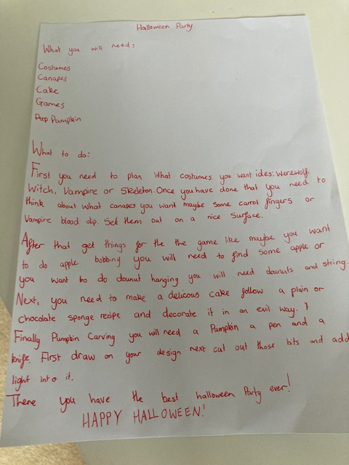

I had my birthday it was a bit different but still my birthday I had some good fun and am now 10!!!

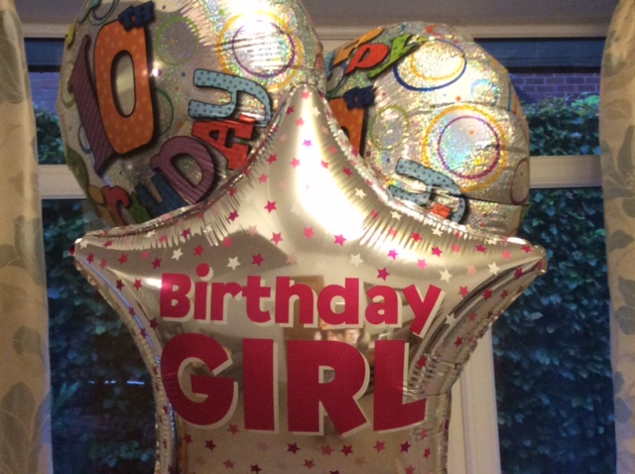

I wrote instructions on a Halloween party. I made a list of what you need and then wrote the instructions

