Jessica’s Newsletter

This week I have been in isolation and this is what I have done:

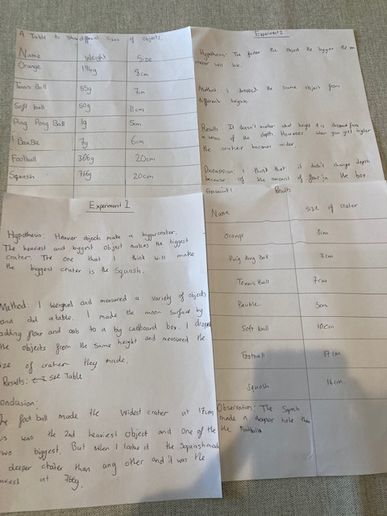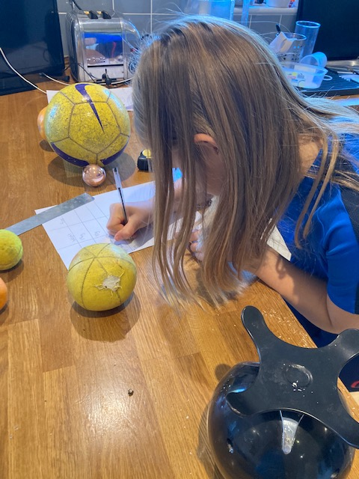

My second experiment I dropped the same object from different heights. I found out it doesn’t matter what height it was dropped from in terms of the depth. However, when you get higher the crater becomes wider.

In science I weighed objects and put them in a chart. I did two experiments, the first one I got flour and oats and added them to a big cardboard box. I then dropped my objects in at the same height. Then measured the size of the crater. Conclusion: The football made the widest crater at 17cm.This was the second biggest object. But when I looked the squash made the deepest crater and it was the heaviest at 766g.

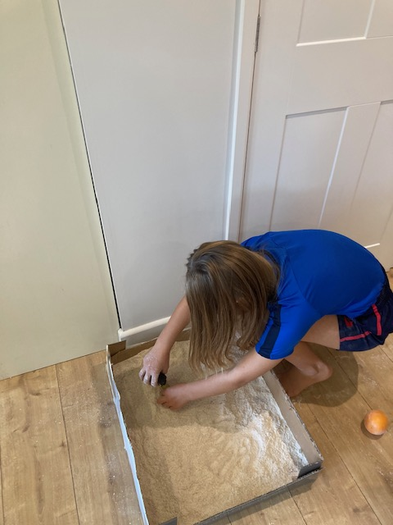 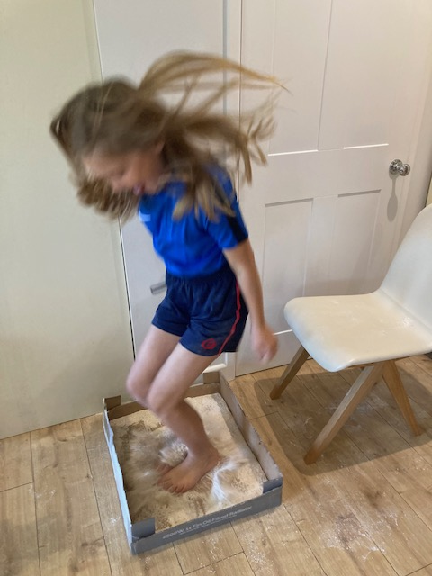

Then I had a go myself!

I then learned about Sir Isaac Newton and wrote an autobiography imagining I was him. 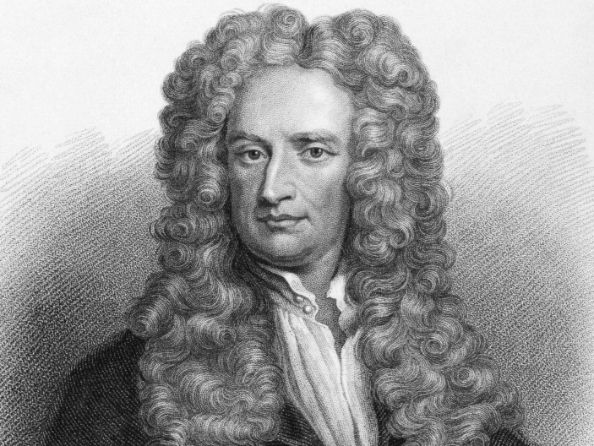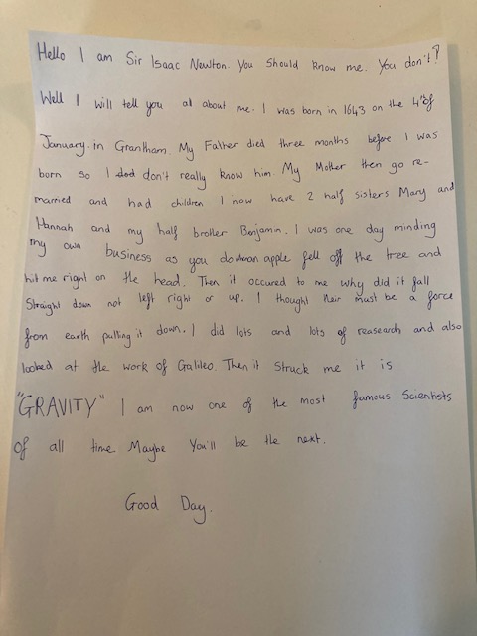

I watched a video on BBC bitesize and looked up some facts about him.

I LEARNED ABOUT AREA AND MEASURED MY ROOM AND MY MUM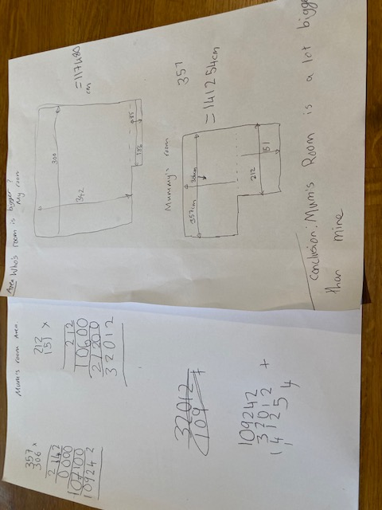 AND DADS ROOM.

I did long multiplication and found out my mum and dad’s room was bigger.

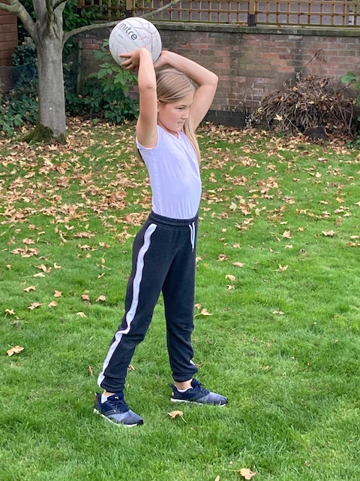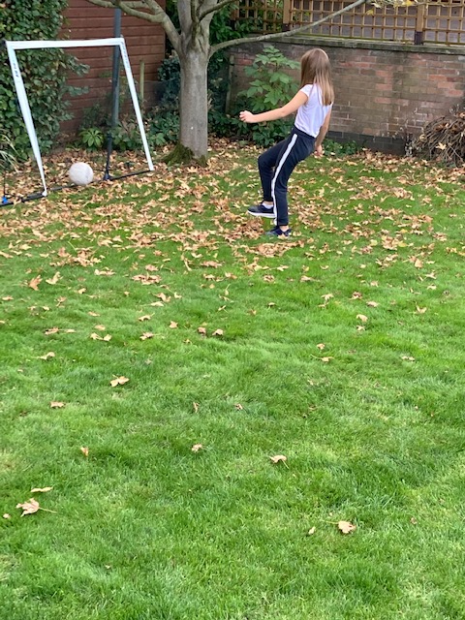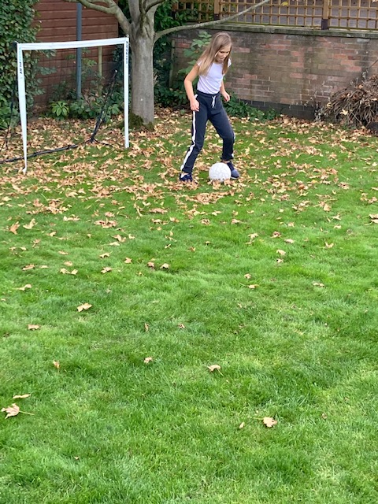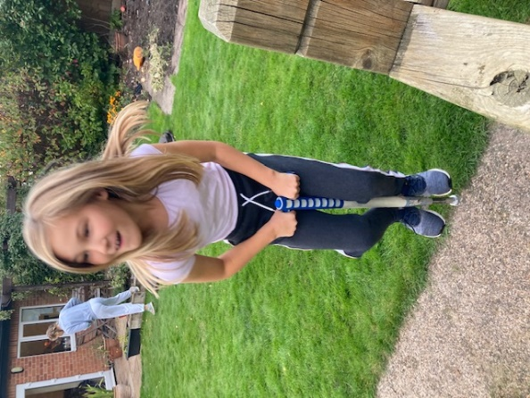

In the week I did lots of sports such as football netball and pogo sticking.

I also did autumn art and Halloween bowls.

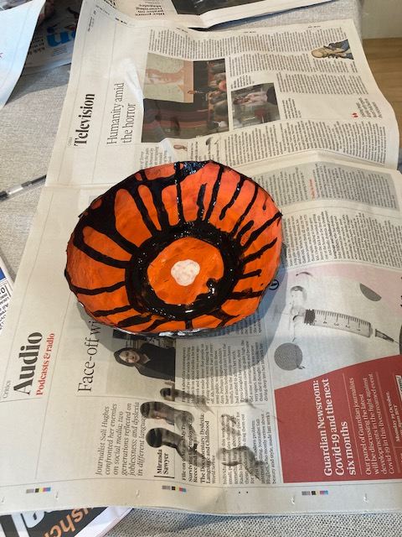

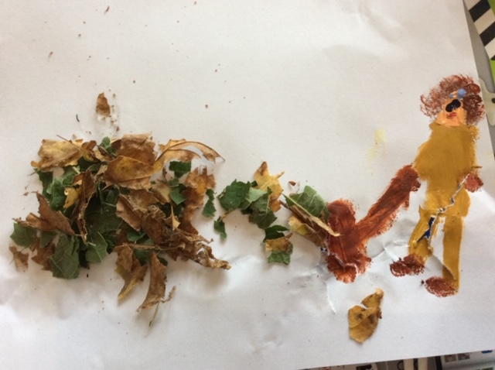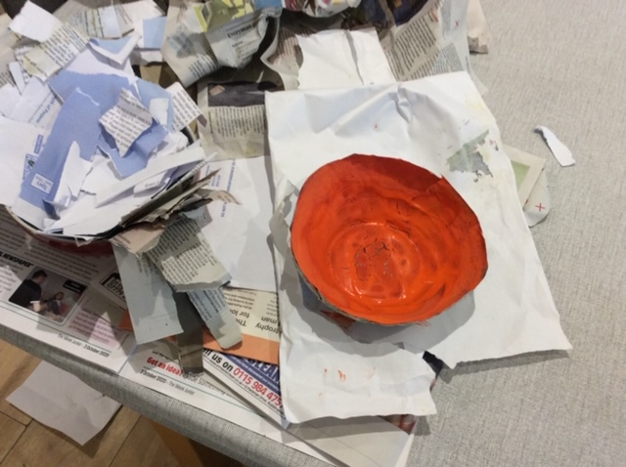

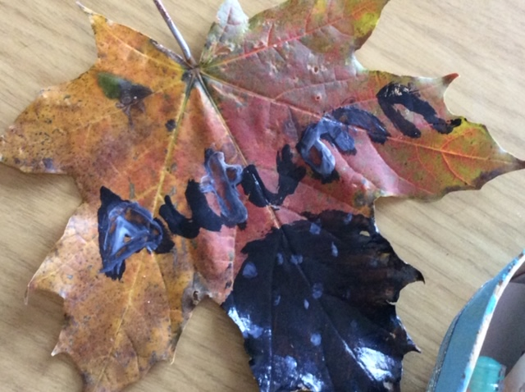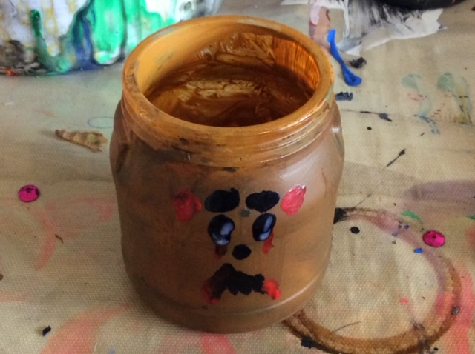

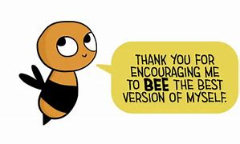

By

Jessica Youatt