Greece



You need to visit this outstanding country as it offers you a load of great views, amazing food and some of the best beaches.



What you can get up to:

Here in Greece you can go for a hike up its tallest Mountain, Mount Olympus.

You can visit one of its amazing beaches.

You can have loads of great fun with the family.

Food:

In Greece they have the most mouth-watering food ever. From yummy flatbreads to its scrumptious Greek salad. You will be amazed with the food here.

Weather:

In Greece you can get 3,000 hours of sun every year. It is a beautiful sunny country.

Facts you might find interesting:

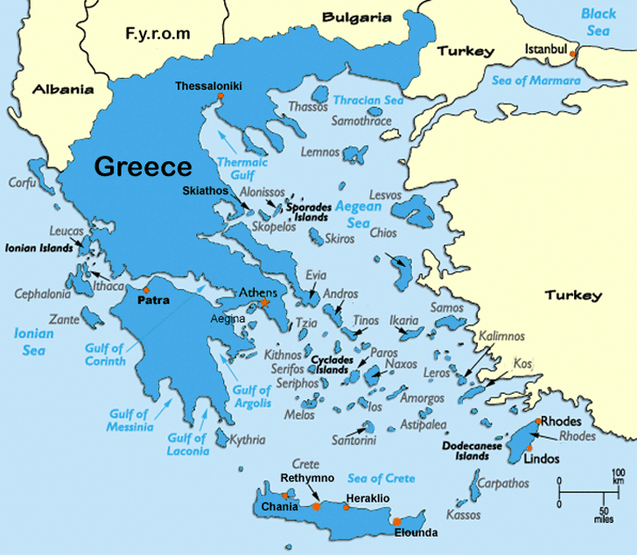

. Greece is part of the E.U.

. It has a population of 10.5 million.

. The capital of Greece is Athens.

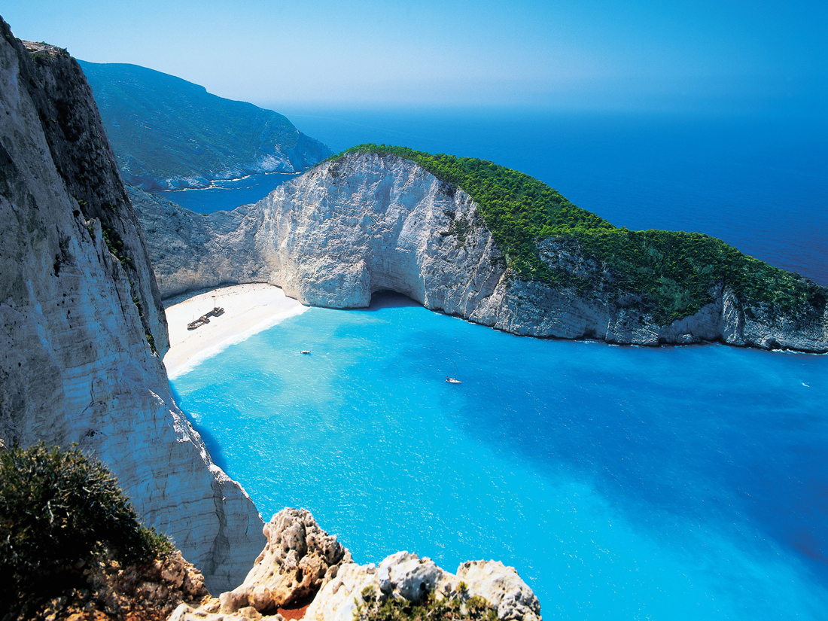

This is where 16.5 million tourists visit each year.