East Bridgford Dads F.C Newsletter February 2025 Issue 7
https://www.justgiving.com/st-peters-ptfa

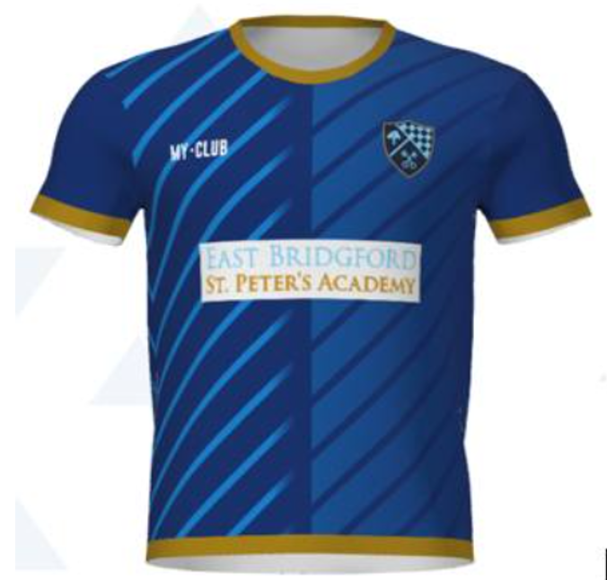

Monday Nights- We meet every Monday at Carlton Le Willows 9pm till 10pm, all are welcome as well as any newcomers, Monday Nights are competitive fun for everyone, we will continue to pop a vote on so ensure all people in group vote! Each Monday is £6 Per Person, please pay in advance.

Fixtures


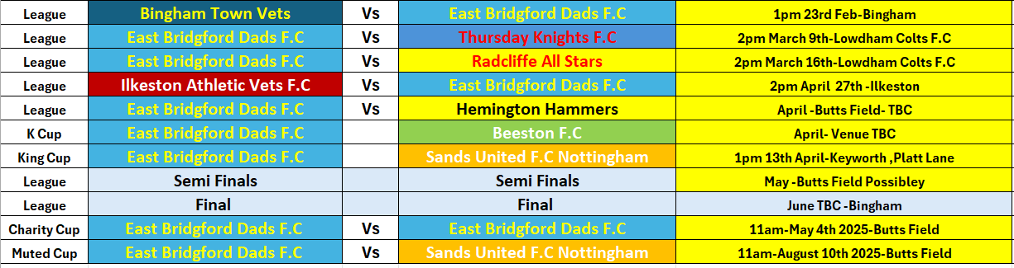

Butts Field Update
We Attended our first Sports Club meeting on Wednesday the 22nd of January with the Parish Council present and they have notified us the damaged caused by the Park Contractors will not likely be repaired before March this year, they are currently flattening the damaged areas and adding grass seed which this will need time to grow, as a Football Club we will keep monitoring this and make any decisions regarding our fixtures nearer the games penciled in as well as leasing with the Parish Council
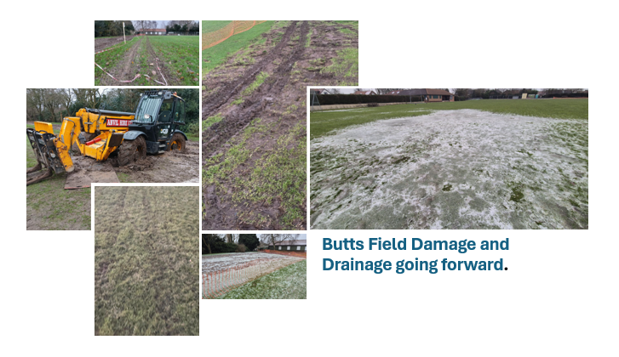

Sports Club Update
As a sports club we are looking to improve the facilities within the club house, we would like to make this more inviting inside.

Anyone who has any comfy sofas or knows of any please let us know as we are wanting to create a comfy seating area in the club and remove the larger tables and replace these with smaller ones that are suitable for a bar/club facility.

Please contact Andy if you can help on 07539 278818

We have also purchased a TV and Pool Table for our Sports Club

There are also some exciting updates coming regarding Food and Catering at the Football and Cricket Club, further updates to follow.




Please come along to
Manchester United Vs Leicester Live F.A Cup tie at East Bridgford Sports Club
On Friday 7th of Feb,
We will be open from 7.30pm
Pool and Darts available!

Please come along to
Aston Villa Vs Spurs Live F.A Cup tie at East Bridgford Sports Club
On Sunday the 9th of Feb
We will be open from 5pm
Family's welcome!
Pool and darts are available!
And a F.A Cup Football Themed Quiz hosted by the Gaffer £2 entry!
Exciting News!
East Bridgford Dads are proud to announce we will be supporting St Peters Academy’s year 5 and 6 football teams starting in 2025 and 2026


Quarter Final Cup Match Vs W.B Notts 26th Jan 2025
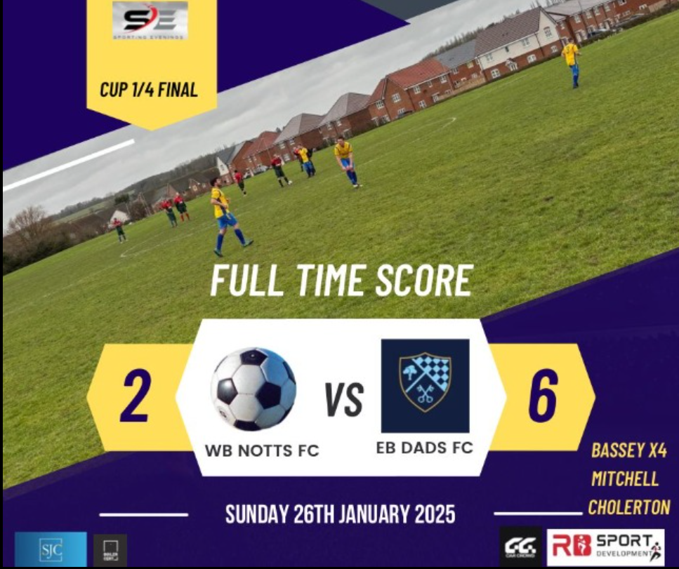
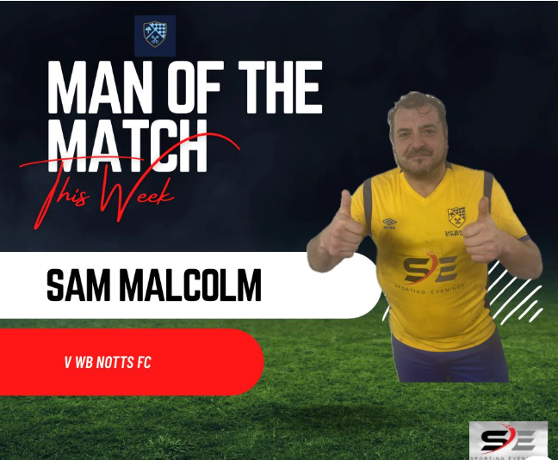



March Back-to-Back Fixtures important update.

Due to the Pitch at Butts Field currently still not fit to fulfill our matches we have moved both our Sporting Evenings League fixtures to Lowdham Colts F.C home ground at Old Tannery Drive, Lowdham.

Massive thank you for Lowdham Colts letting us play and use their facility’s

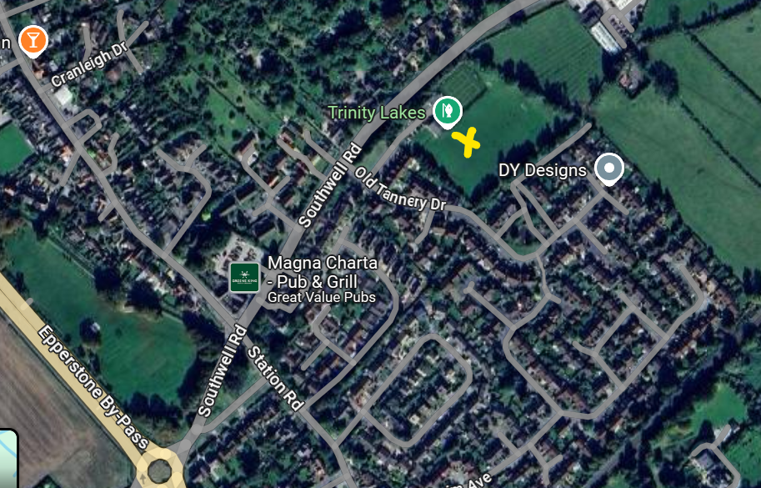
Venue Address: Lowdham Community Building Old Tannery Drive (just off Southwell Road) NG14 7PS
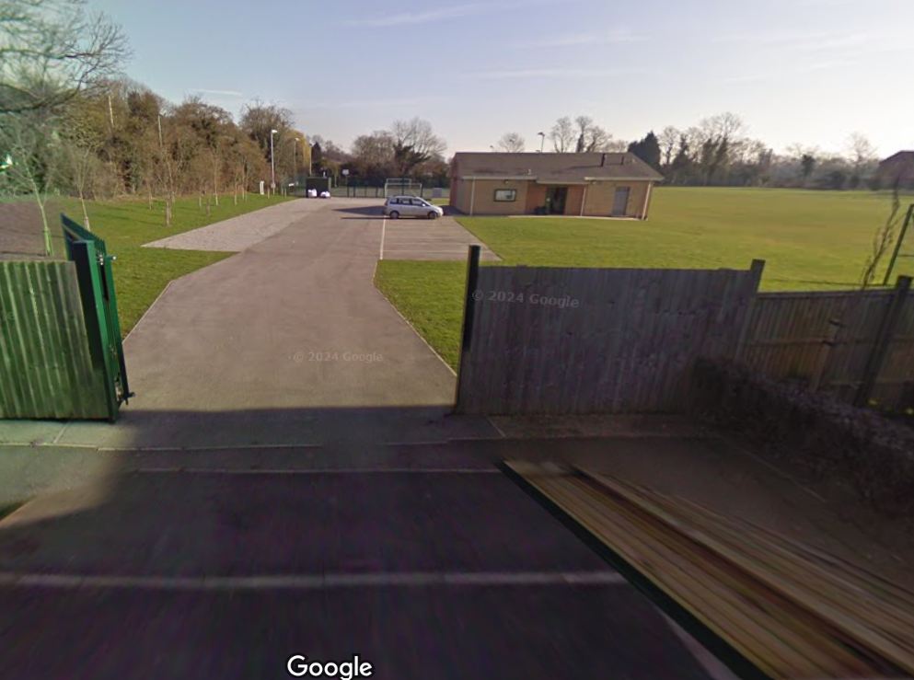
What’s Coming Up?
Please come along on the 13th of April and support the East Bridgford Dads in the below charity tournament , our friend’s at Sands United FC Nottingham have invited us along and we can’t wait to take part and raise funds for a valuable cause.



Dates for your Diary’s!

Ball Boy’s/Girls at Grantham Town

Your Club Captain



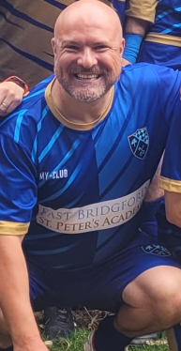
Message from the Gaffer

Great to wear our new away kit recently in our match Vs W.B Notts, massive thankyou to Logo me up in Bingham for the amazing printing and as ever Steve at Sporting Evenings for sponsoring our shirts.

Also, as always special mention to all our sponsors thanks for your ongoing support.

I am really excited about the remaining season, the cup quarter final win was a superb performance, and we are sat in a great position in the League.
We have a cracking squad where I am confident, we have 2 great players now in every position so there is going to be plenty of healthy competition to get into the starting lineup which as a manager excites me as well as gives me a headache!!



Our Club Structure
- Manager-Andy Allam
- Assistant Manager-Richard Povey
- Treasurer- Andy Allam
- Club Secretary- Andy Allam
- Website Manager-Richard Povey
- Club Captain- Stuart Turner-Haslam
- Vice-Captain- Ant Hogan
Our Club Sponsors -

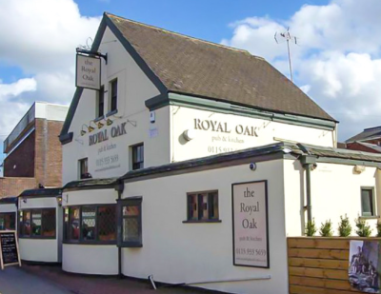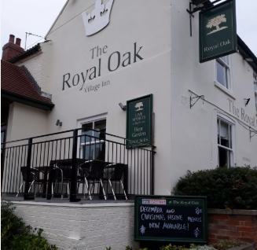

Club Shop
Hoody £25

Coat £40
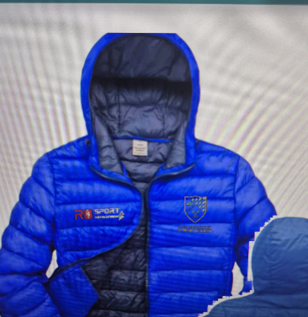

Home Kit-£35
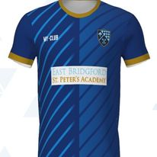
Beanie Hat- £10







