East Bridgford Dads F.C Newsletter March 2025 Issue 8
https://www.justgiving.com/st-peters-ptfa



Monday Nights- We meet every Monday at Carlton Le Willows 9pm till 10pm, all are welcome as well as any newcomers, Monday Nights are competitive fun for everyone, we will continue to pop a vote on so ensure all people in group vote! Each Monday is £6 Per Person, please pay in advance.

Fixtures


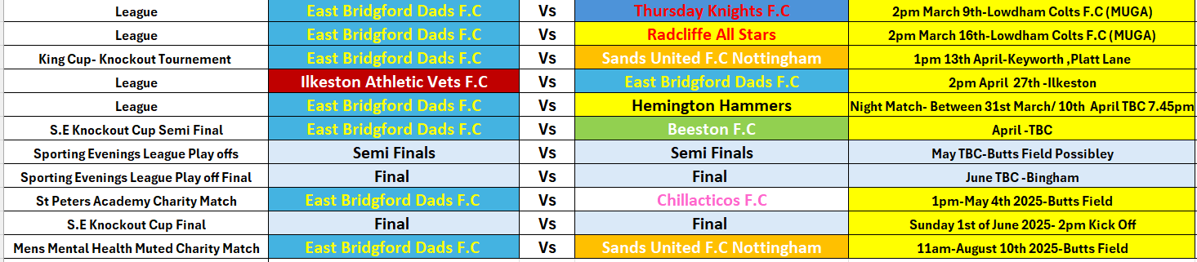

Butts Field Update
At Present the Parish Council and Park Contractors that caused the damage to our Home Pitch at Butts Field are unable to start the work required due to the current weather and time of year.
East Bridgford Dads Manager Andy has put in a grant application to East Bridgford Parish Council to request 2 new goals that fold and can be rolled out on wheels this is due to us having to shorten the pitch at the Scout Hut End and extending it slightly at the Skate Ramp End, due to the fixed goals we used and new nets that we had purchased we would not be able to use these at present so we are hoping that we get a grant and support from the Parish Council to get our Charity games on very soon.
I would really appreciate if as many players could attend the next Parish Council meeting with Andy to support him with this request on the 10th of March 2025
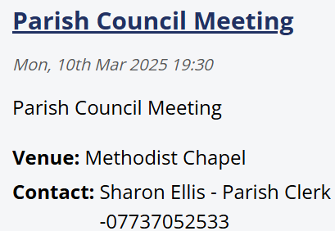
Sports Club Update
As your aware a number of us worked really hard in the previous month to try and make the Sports Club more inviting, we were clearly encouraged by East Bridgford Parish Council at our last Sports Club Meeting to go ahead and do this, sadly since then there seems to have been a breakdown in communication and as a Sports Club where notified events need to be held on the field for us to open the Sports Club, as you can imagine this is extremely frustrating considering we went out and purchased a new T.V, Pool Table and was donated some new Bar stools and Darts Boards.

As most people are aware at no point where we turning this into any type of social club that seemed to be perceived, the idea was to improve facility’s and making this more inviting encouraging the community to come together to ensure indoor facilities as well as outdoor facilities where utilized

I had several inside charity events planned to raise not only valuable funds for the Sports Club but also several of Charity’s close to our hearts sadly these have now had to be put on the back burner and change of venues will be required.

Regarding catering I have decided to also now no longer pursue this for the Sports Club due to lack of encouragement and support but on our larger Football Charity events I will ensure I work with local companies to supply us on our special days.



Sporting Evenings League Match Day 4
Bingham Town 2 East Bridgford Dads 2
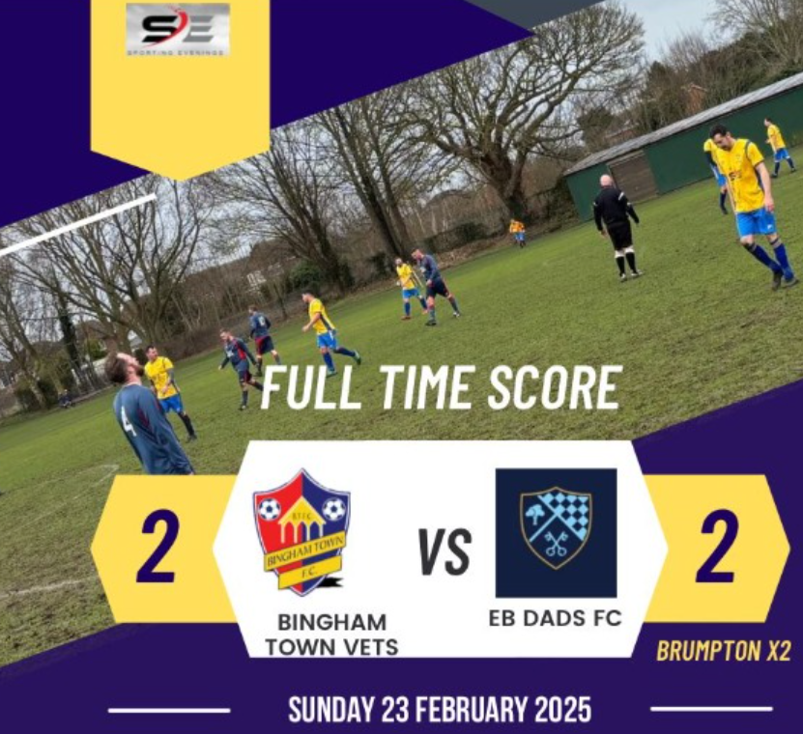

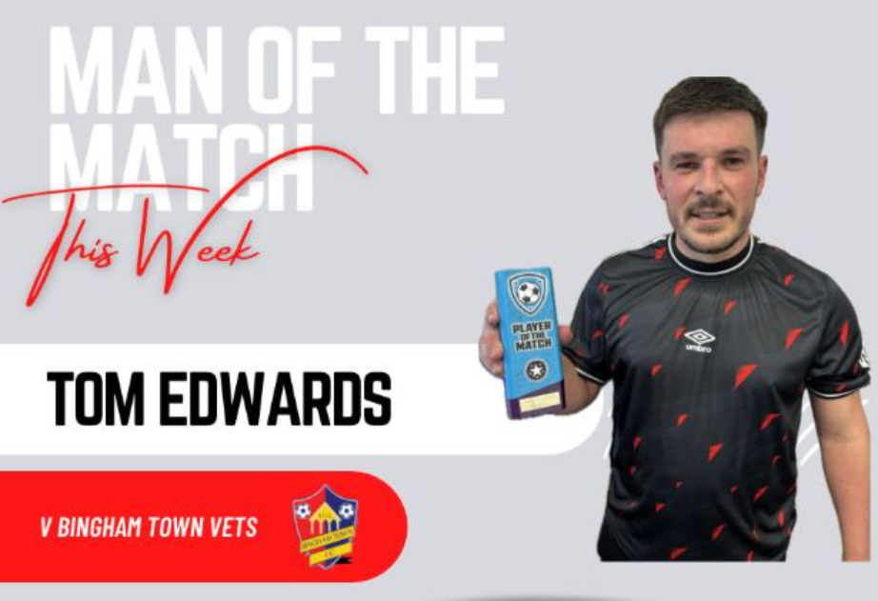


Sporting Evenings Latest League Table March 2nd, 2025

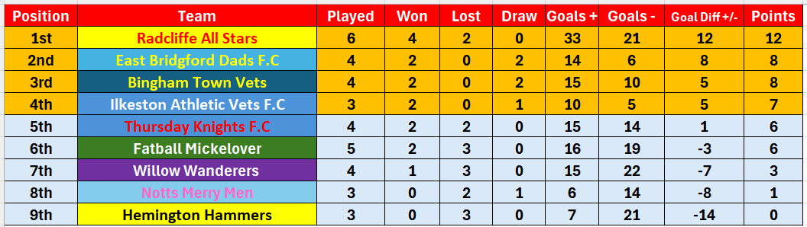

East Bridgford Dads F.C Top Scorers

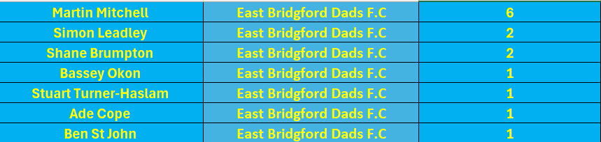






March Back-to-Back Fixtures important update.

Due to the Pitch at Butts Field currently still not fit to fulfill our matches we have moved both our Sporting Evenings League fixtures to Lowdham Colts F.C home ground at Old Tannery Drive, Lowdham.

Massive thank you for Lowdham Colts letting us play and use their facility’s

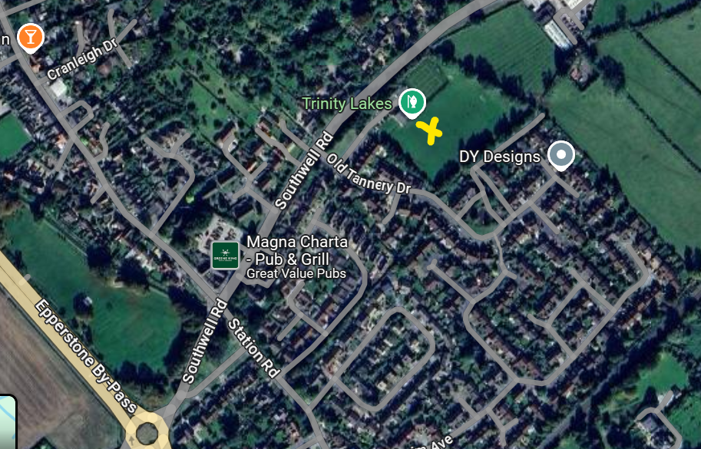
Venue Address: Lowdham Community Building Old Tannery Drive (just off Southwell Road) NG14 7PS
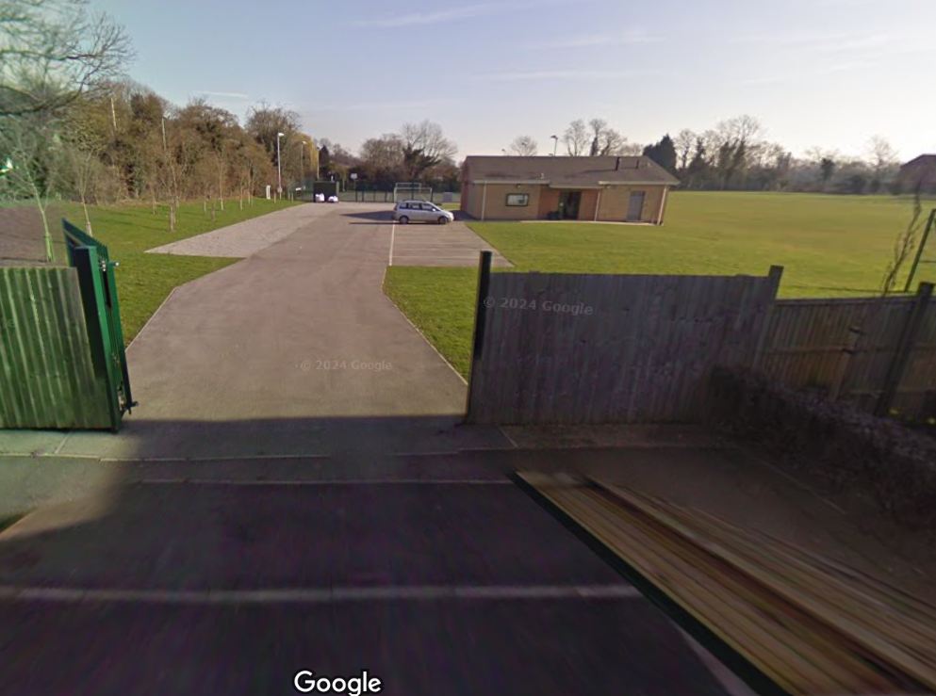

What’s Coming Up?
Please come along on the 13th of April and support the East Bridgford Dads in the below charity tournament , our friend’s at Sands United FC Nottingham have invited us along and we can’t wait to take part and raise funds for a valuable cause.



Dates for your Diary’s!

Ball Boy’s/Girls at Grantham Town

ST PETERS ACADEMY TROPHY 2025
SUNDAY MAY 4TH 1p.m




Meet Your Assistant Manager



Meet Mr. Versatility




Message from the Gaffer

Well, what a superb effort from all the squad at Bingham Town, in my opinion we were the better team especially in the second half but sadly we just couldn’t get that winning goal.

Want to say huge shout out firstly to all the supporters who attended in blustery conditions, your support means a lot to all of us and its great seeing so many faces coming along to cheer us on.

Also huge thank you to all the players that attended and didn’t sadly get a run out due to how tight the game was at the time

Massive thank you to Kit for doing the warmup drills as well as all the guys that ran the line for us, we really do have a great team spirit, and I am proud to have everyone on board.

Well, we have plenty to look forward too, 2 back-to-back games this month which I am hoping to get 6 points which will only cement out place in the top 4 and get us into the league playoffs, we also have a cup semifinal to schedule in with Beeston so exciting times for the East Bridgford Dads.

Plans are now in place for our yearly fundraiser on the 4th of May so really looking forward to going in to the school to meet the children again and raise some much-needed funds for them.

Hope everyone has a great month!

Our Club Structure
- Manager-Andy Allam
- Assistant Manager-Richard Povey
- Treasurer- Andy Allam
- Club Secretary- Andy Allam
- Website Manager-Richard Povey
- Club Captain- Stuart Turner-Haslam
- Vice-Captain- Ant Hogan

Our Club Sponsors –



Club Shop
Hoody £25

Coat £40


Home Kit-£35

Beanie Hat- £10







