East Bridgford St. Peter’s Academy – Year 2 Weekly Newsletter

Teachers: LW & LF | Homework Subject: History | Date: 27/1/2017

Dear Parent(s),

This week we have started learning about Explanation Text using Wallace and Gromit’s Cracking Contractions. The children have looked at features within them and analysed examples of explanation texts. The main features are: a clear title, subheadings, ideas grouped in paragraphs, clear introduction, time conjunctions, cause and effect conjunctions (because, so, in effect). In maths, we have recapped our times tables focusing on 10’s, 5’s and 3’s. We then used our knowledge of multiples to solve division calculations; knowing that we can use the inverse to solve the problem. Please continue to learn these at home.
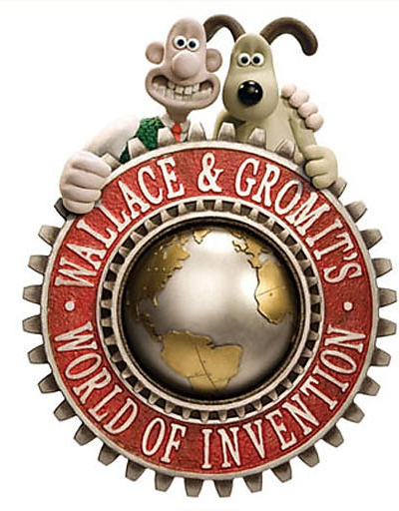
This week was Dylan’s Family Box where he confidently and fluently discussed items including a fluffy hawk which he particularly likes as it is his surname. He showed photographs of himself as an astronaut at the National Space Museum. He also shared photos of holidays he has enjoyed to both Lanzarote and Greece. Dylan has rabbits and a playful cat called Obie and he showed us his cat’s favourite toy. Monopoly is Dylan’s favourite board game and he enjoys playing with his family. Dylan often travels to London to see his cousins there. Football is Dylan’s much-loved sport where he plays for EBFC- his dad even coaches too! Dylan explained that he enjoys LEGO as his hobby and likes to build and create all sorts of designs. We have Family Box time every Friday afternoon, next week is Jacob Holt’s Family Box. Please could we ask that in the box you also include a carrier bag so that items can be returned home safely.

Dates to note:
- Indoor PE every Friday.
- Outdoor PE every Tuesday.
- Inset Days: Friday 10th February
- Please note: change in date: Tuesday 21st March at 5.00- 5.30pm in Class 2 – Parent Meeting: Year 2 SATs and Willersley castle

HOMEWORK THIS WEEK:
In History this half term, we have started ‘The Great Fire of London’ topic, the children sequenced key events in the Stuart era such as; 1603 James VI of Scotland becomes James I of England uniting the two kingdoms, 1605 5 November - Gunpowder Plot to assassinate James I is discovered Guy Fawkes is thwarted when he tried to blow up Parliament, 1660 Samuel Pepys starts to write a diary, 1664-5 The Great Plague, 1666 The Great Fire of London. We would like the children to find out a about The Great Fire of London; this could be how, why it happened, who was affected, photographs of before/after, information on Samuel Pepys. Please could this be on A4 paper either handwritten or typed up in a TAKE CARE way (but doesn’t need to be presented like the Nottingham topic). This will be shared and then put into their history file.

Many thanks,
Miss Wright and Miss Fisher
To be returned by: 3rd February 2017.

