East Bridgford St. Peter’s Academy – Year 2 Weekly Newsletter

Teachers: LW & LF | Homework Subject: SPAG | Date: 02/12/2016

Dear Parent(s),

Although, we are coming close to the end of term we feel it is important to ensure that structure is maintained especially during literacy and numeracy time. In literacy, this week we have been focusing on how to write instructions using; time conjunctions, imperative verbs (place, put, add, scoop) and adverbs to create our own instructions for building a snowman. We imagined we were writing it for a child who had never even seen snow before so detail was important. In maths, we have been learning to how to find fractions of shapes and quantities/numbers. We learned how we can use our knowledge of 2’s to solve ½ of numbers. When solving problems that involved ¼ or ¾ of a number we showed the children how this can be done in a visual and kinaesthetic way (see below). This helped the children understand how the number starts as a whole and can be split up into equal parts. We explained that the denominator (the bottom number) is how many parts/sets there are in total and the numerator (the top number) is how many sets there are being counted.

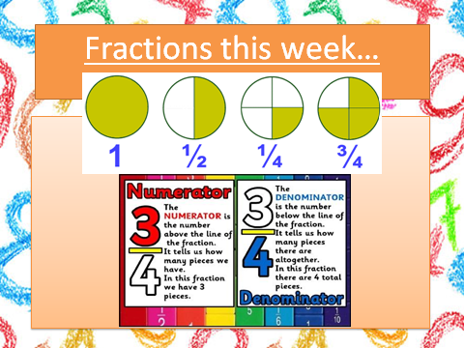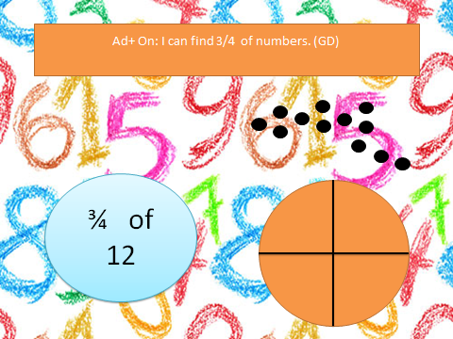

We start with the quantity/ number then share it out into the 4 parts equally to find 1/4 , 2/4 or 3/4

For example:
¼ of 12 = 3
2/4 (which is the same as 1/2 ) = 6
¾ of 12 = 9

Family Box
This week was William Cresswell’s family box. William shared photographs of his friends that also live Newton, including some children in year 1. William shared memories from a seaside holiday. William enjoys playing football on a Thursday – he has even won Man of the Match Trophy. William shared a photograph with all of his family including; William’s granddad, who works for the Police Force. William enjoys ‘Where’s Wally?’ books and has a book set that he shared. William enjoys making lego models and made a model without any instructions! Thank you for sharing your family box William.
We have Family Box time every Friday afternoon, next week it is Ben’s family box. Please could we ask that in the box you also include a carrier bag so that items can be returned home safely.

Save the Snowmen
The children have been very excited about our “save the Snowman” mystery. Schools from all over the world are involved in clue finding to locate the missing snowman. Follow and find our more at: https://savethesnowmen.wordpress.com/
THE MISSION: Children all over the world…your help is needed! It has been noticed how much help the snowmen give to Santa Claus and the elves every Christmas. It has been noticed how hard the snowmen work and how helpful they are. So now… the snowmen have been stolen! They have been taken somewhere to work and help somewhere else! But the snowmen want to go home. Lapland won’t be the same without them this Christmas and Santa and the elves miss them so much.
The only problem is the snowmen don’t know where they are. Can you help locate them?

Dates to note:
- Indoor PE every Friday
- Break up for Christmas: Friday 16th December
- KS1 Production on Thursday 8th December at 2.30pm
- Week beginning 12th December, please bring in your wooden spoon to school. We aim to have a crafty afternoon to ensure our puppets are made.

HOMEWORK THIS WEEK:
Please see the attached SPAG sheet to complete.
Weekly optional handwriting homework. Some children have requested extra handwriting. This is up to your child if they would like to do it to improve their handwriting and complete the practice sheets. This homework does not need to be brought into school as it is just an improvement prompt for children to take independence in their own learning.

Many thanks,
Miss. Wright and Miss. Fisher.
To be returned by: 9.12.16

