East Bridgford St. Peter’s Academy – Year 2 Weekly Newsletter

Teachers: LW & LF | Homework Subject: Nativity Practise | Date: 25/11/2016

Dear Parent(s),

This week we started our Literacy topic based on an American Christmas advert ‘Lily and the Snowman’. You can watch the short clip here: http://www.literacyshed.com/lilyandthesnowman.html The advert sees a story of a young girl who forms a friendship with a snowman but as she grows older she no longer has time for him so she keeps him in a freezer. The advert then shows the little girl grow older and she remembers him which leads her to return to her childhood home to find him still in the freezer. It’s a really sweet advert. The children have enjoyed using coordinating and subordinating conjunctions to write compound and complex sentences about the story. See below for further explanation of these. In maths the children have learnt and recalled the 2, 5, 10 and now 3 times tables. We used arrays to solve problems and also challenged the children to solve ‘mastery’ style questions that require the children to ‘reason’ and ‘explain’ their answers!

CONJUNCTIONS EXPLAINED!

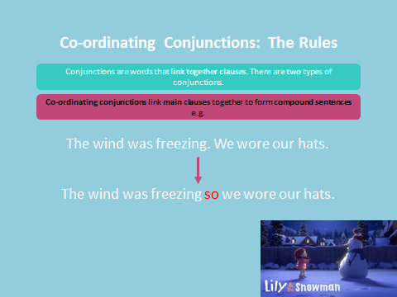
Examples of Coordinating Conjunctions:

For, and, nor, but, or, yet, so

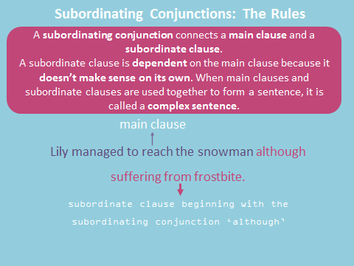
Examples of Suborndationg Conjunctions:

When, that, after, since, even though, if, as.

This week was Harry Cox’s family box. Harry enjoys lots of sports; he plays table tennis every Thursday after school at our school. Harry supports Nottingham Forest and Manchester United, he plays football with a few boys from Class 2. Harry has a gorilla names Gabriella – he enjoys playing hide and seek with his brothers; hiding Gabriella around the house. Harry loves his brothers and Harry shared Oliver’s favourite book which is The Lion, The Witch and The Wardrobe. Harry explained what happens in the story with great detail referring to the characters and the magical wardrobe. Harry enjoys reading Horrid Henry books and likes Rude Ralph the best. Harry enjoys colouring with his brothers and he was very kindly given a ‘complicated colouring’ sketchbook. Harry had such an adventure over the summer; he started his adventure from England and then went to…Wales to Belgium to Germany to Czech Republic to Poland to Lithuania and finally Riga in Latvia (which is where Harry’s mummy was born). He then finished it off by visiting Scotland! Harry LOVES Star Wars and brought in a light saber to share. Harry attends Church every Sunday and he loves ‘Munch and Mingles’ where he gets to eat lots of lovely food. Harry spoke so confidently and with lots of passion – thank you Harry! We have Family Box time every Friday afternoon, next week it is William Cresswell’s family box. Please could we ask that in the box you also include a carrier bag so that items can be returned home safely.

Dates to note:
- Indoor PE every Friday
- Outdoor PE every Tuesday – next week will be the final one until Spring Term due to rehearsals.
- Break up for Christmas: Friday 16th December
- KS1 Production on Thursday 8th December at 2.30pm

Spellings:
Just a note that we recommend that children practise their words from the Year 2 Spelling Lists (on the website too) once a week. We have noticed words that contain ‘wr’ ‘kn’ ‘dge’ can be easily misspelt. We have practised words such as: write, written, writing, knew, knife, know, bridge, dodge, fudge etc - these are also on the Year 2 Spelling for Parents sheet. We appreciate how busy life can be but even if it’s for 5 minutes and focusing on 3 or 4 words – this will help! Practising by Looking, Covering, Writing and Checking – then repeat. Any practise will really benefit the children’s learning and this mirrors what we do daily in school.

HOMEWORK THIS WEEK:
Please practice performance presence, volume of voice and expression with your child. They have their lines to learn and most of the children already know them! Well done to them, they made us very proud in the first rehearsal today.

Many thanks,
Miss. Wright and Miss. Fisher.
To be returned by: n/a

