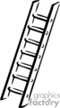  Long Ladders (down and off in another direction) | 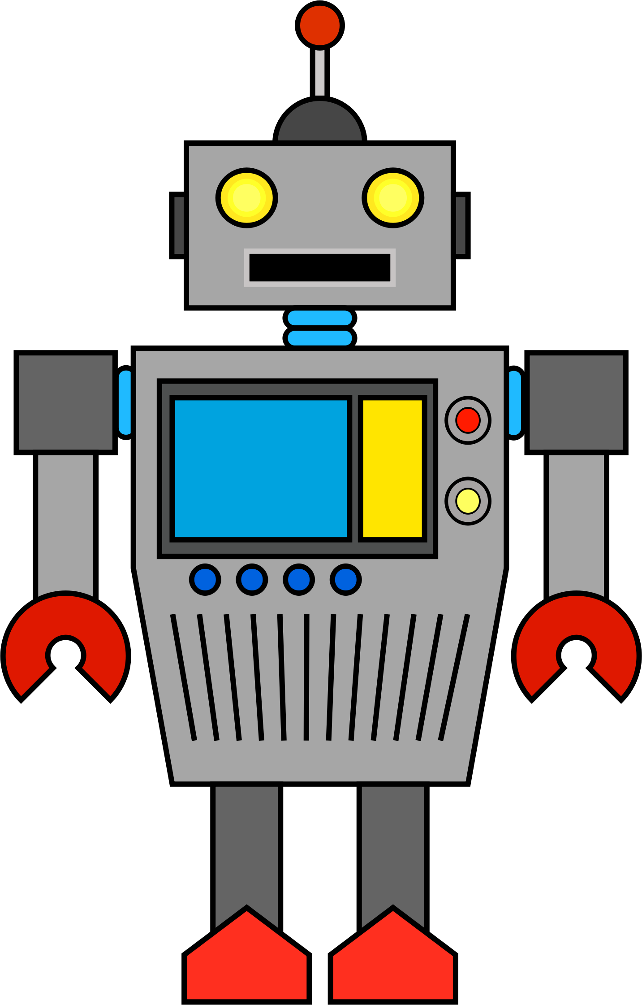  One armed robots (down and retrace upwards) | 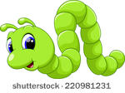  Curly Caterpillars (anti-clockwise round) | 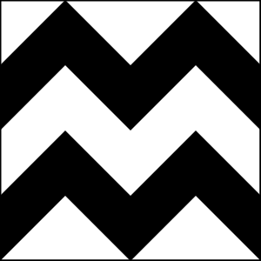  Zig Zag letters
l, i, j, t, u, y | b, h, k, m, n, p, r | c, a, d, e, g, o, q, f, s | v, w, x, z

