Miss Peckover – an Acrostic Poem

[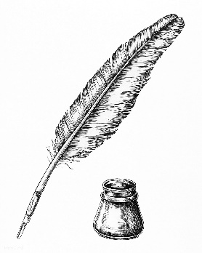](https://www.google.co.uk/url?sa=i&url=https://www.pinterest.com/pin/339318153176038872/&psig=AOvVaw0eAw3HVxbZ7klmDuZbB5lL&ust=1589553584562000&source=images&cd=vfe&ved=0CAIQjRxqFwoTCPjexNrKs-kCFQAAAAAdAAAAABAD)**M**arvellous hand-writer

**I**nspiring teacher

[](https://www.google.co.uk/url?sa=i&url=https://www.theguardian.com/commentisfree/2014/nov/02/sharkespeare-marxism-feudalism-capitalism&psig=AOvVaw10XUVAt-4wIrDwlYEAQ9n4&ust=1589552483468000&source=images&cd=vfe&ved=0CAIQjRxqFwoTCPC6kc3Gs-kCFQAAAAAdAAAAABA8)**S**hakespeare enthusiast

**S**piky, black hair

[](https://www.google.co.uk/url?sa=i&url=https://www.kvraudio.com/forum/viewtopic.php?t%3D530683&psig=AOvVaw2pCTFEmnRxZuCMsqCpFQWB&ust=1589552922144000&source=images&cd=vfe&ved=0CAIQjRxqFwoTCIiVmZ7Is-kCFQAAAAAdAAAAABAe)**P**lay director

**E**ncourages children to act

**C**licky finger (“Start acting!”)

[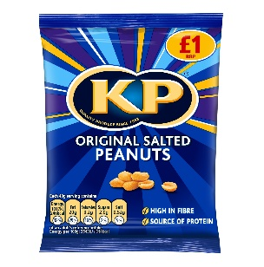](https://www.google.co.uk/url?sa=i&url=https://www.talkingretail.com/products-news/crisps-snacks/new-look-kp-nuts-22-04-2016/&psig=AOvVaw0lhHQILtrzeJ6hU92t1Ayg&ust=1589551567382000&source=images&cd=vfe&ved=0CAIQjRxqFwoTCPjy89_Hs-kCFQAAAAAdAAAAABAD)**K**.P. is her nickname (like the nuts!)

**O**nly wants your best work

**V**ery hardworking

**E**lvis lover (uh-huh-huh)

**R**etired in 2020. K.P. has left the building!

[](https://www.google.co.uk/url?sa=i&url=https://en.wikipedia.org/wiki/Elvis_Presley_on_film_and_television&psig=AOvVaw2EerlE-PRfJ93CEEpgyiFu&ust=1589553314164000&source=images&cd=vfe&ved=0CAIQjRxqFwoTCMjynNzJs-kCFQAAAAAdAAAAABAD)

By Joe Ridgway

Happy Retirement!