**Mary Jackson**

Mary Jackson was an American mathematician and aerospace engineer. She was BORN on the 9th of April 1921 and died on the 11th of February 2005 at the age of 83. In here life, she helped other women to become like her.

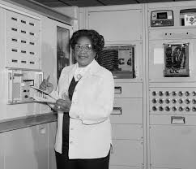She worked for NASA from 1956 to 1985. She is famous today because she was the first African/American engineer ever. She had two children, Carolyn Marie Lewis and Levi Jackson jr. here parents were Ella Scott Wilson and frank Winston.