
St. Peter’s Academy – Upper KS2 Team Weekly Newsletter

UKS2 Teachers/Teaching Partners:  Mrs. Marston Class 5 Teacher  Miss. Brownley Class 5/6 Teacher  Miss. McHugh Class 6 Teacher  Mrs. Smith UKS2 Teaching Partner | Homework Subject:  Romeo and Juliet Diary | Date:  Thursday 28th September  Due – Thursday 12th October

This week:
Lots of activities to report on this week! We were visited on Tuesday afternoon by Image Theatre who put on an amusing production of The Selfish Giant. A fantastic time was had at the Flintham Show! Thank you to those parents and carers who joined us as volunteers, we hope you enjoyed the day as much as we did. Well done to anyone who entered competitions at the show. A big ‘good job’ to all UKS2, we are very proud of your take care attitude and how you represent our school.
Year 5 ONLY – Condover next week! Please reread and make yourself familiar with the letter that was sent home a couple of weeks ago regarding Condover. This has a full kit list on it and details of how the week is organised.
Homework:

ALL UPPER KEY STAGE 2 ‘Take Care’ signature homework:

Your homework over the next two weeks is to prepare your Romeo and Juliet diary entries and present them in a ‘take care’ way. Some of you have started writing these up in best but this will need to be finished as part of the homework, or typed. This is a signature piece of homework that is bespoke to Upper Key Stage 2, and will be presented in each classroom. There are some photographs of previously presented Shakespeare diary entries below which you have all had a chance to see during school time. (N.B – Please do not send any glass bottles into school, plastic only, or anything that is of value to you, as these will be on display for the duration of the year).

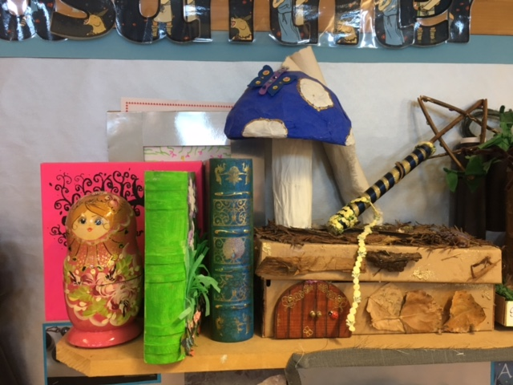
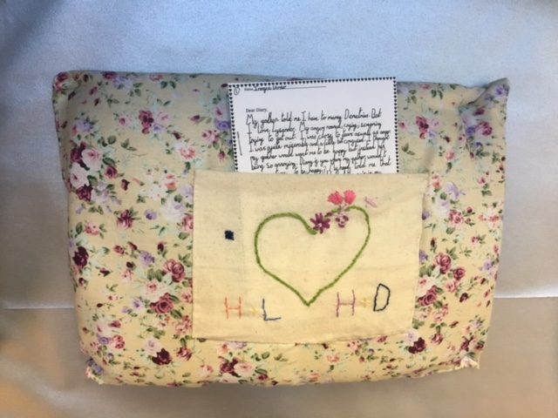

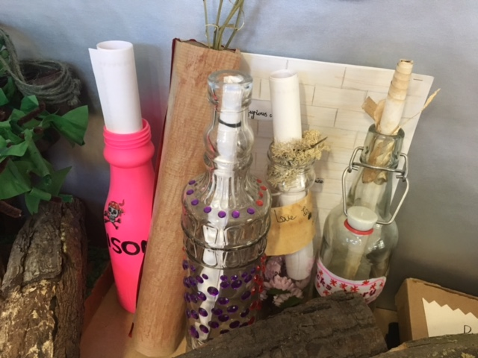

To be handed in Thursday 12th October (or before).
We have provided 2 weeks for this homework to allow Year 5 children, who are at Condover, to have adequate time to prepare this signature work.

Weekly and General Reminders:
PE is on Wednesday and Friday (both outdoor).
Condover 2nd Oct for whole week (Year 5 only).

Lunchtime clubs
Monday – Chess
Tuesday – Football
Wednesday – Lacrosse
Thursday – Tennis
Friday – Cross Country

Dates to note:
YEAR 6 ONLY – DARE Life Skills Education (to begin Friday 15th September – Dec 2017)
YEAR 5 ONLY – Condover Residential 2nd October-5th October 2017.

ALL- Parent’s evenings Weds 11th and Thurs 12th October 2017.

*Future date – SATs week 2018 – Monday 14th May – Thursday 17th May 2018*
*Future date - YEAR 6 ONLY - Year 6 Residential to Whitby – June 27th, 28th and 29th 2018*
Homework due in – Thursday 12/10/2017 (or before).

