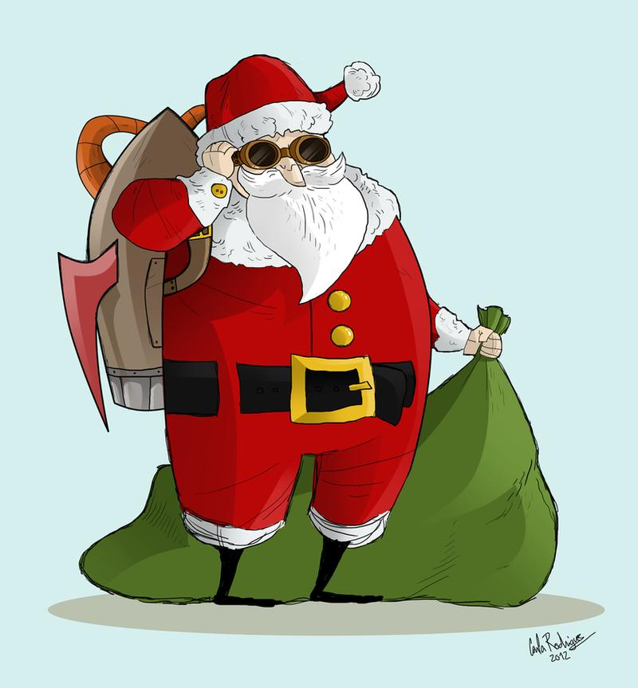

St. Peter’s Academy – Miss Brownley Weekly Newsletter

UKS2 Staff:  Mrs. Marston – Teacher 5/6  Miss. Brownley – Teacher 6  Mr. Jennings – Teacher 5  Mrs. Peach UKS2 Teaching Partner | Homework:  - Times tables puzzle  - Spellings (in diaries)  - Maths (dividing fractions by integers)  - Maths (A5 challenge sheet) *optional | Date set: 6th Dec  Due: 13th Dec

This week:
It’s officially starting to look a LOT like Christmas, and with 2 weeks before we break up I am slightly nervous [actually, petrified] about how excited we all already are in Class 6 (including me!). We decorated the classroom this week and the children were pleased to see the return of the tacky tree. They have also decorated the board and around the room, which really started off our Christmas festivities at the beginning of the week. If you haven’t seen the tacky tree, come and have a look – it is a sight to behold.

Please have a look at the dates below which tell you what’s happening and how it affects our class in the run up to Christmas.

Homework: We will mark these in class each Friday morning and go through any misconceptions.
- Times table puzzle (number 4)
- Spellings – personalised in diary.
- Maths (dividing fractions by integers)
- Maths (A5 challenge sheet – to promote discussion, problem solving and reasoning skills). *optional
As always, if children have any issues or need a hand with their homework, I am happy to go through it with them during assembly slots as long as they let me know in plenty of time and before the day it is due in.
Last 2 Weeks before Christmas – Dates to Note:
- Thursday 12th Dec – Whole School Panto – school uniform please (festive head/hair accessories encouraged ☺)
- Friday 13th Dec – Christmas Jumper Day (Christmas jumper and normal school uniform on the lower half) and UKS2 Silent Disco 1:30-3:30pm (Disco clothes can be bought in separately if required, and the children will be able to get changed for this just before lunch).
- Tues 17th Dec – Christmas Dinner Day (let the carnage commence!)
- Weds 18th Dec – KS2 Carol Concert (See Mr. T newsletter for info)
- Thurs 19th Dec – Choir Singing at John Lewis (remaining children with Miss Brownley)
- Fri 20th Dec – Final Day! Merry Christmas.

