St. Peter’s Academy – Miss. Brownley’s Year 1 Weekly Newsletter

Teacher: Miss Brownley.  TP: Mrs Peach, Mrs Wale & Mrs Cox. | Homework Subject:  My Family History | Date: Thurs 20/10/16

This Week:
Happy Half Term ☺! What a fantastic start to the academic year we have had.
Thank you to everyone who joined us for the ‘big squeeze’ this week, in other words our Harvest Festival! We hope you enjoyed watching us being dingly and dangly Scarecrows ☺ We really loved singing for you in church. As I’m sure you are aware tomorrow is an INSET day, so the children are not in school. A quick reminder if you haven’t done so already, please could you return your child’s Ferry Farm slip to let us know if they are coming or not. If you need an additional copy please see the website.

Tennis did not go ahead this week as at the time the decision was made to cancel it was raining heavily and would have been unsafe for your children. Typically, it was then gloriously sun-shining at the end of lunchtime however it would have been wet underfoot. Ruth will make this lesson up next term.

PE Update:
As the weather is now becoming damp the field can get very wet and this makes PE outdoors slightly hazardous. If it becomes too wet outside we will make a decision to come indoors and do PE in the hall. We will usually have to make this decision on the day. Please ensure your child has appropriate footwear for both outdoor and indoor PE on Tuesday, Wednesday and Friday. (Friday PE will always be indoor with Gordon).

Diaries:
We are still waiting for these to be delivered! When these come in I will provide information as to how you can use these to record when you have read with your child.
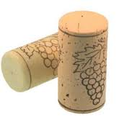
Christmas Craft Help
Thank you for all the corks we have received so far! Please could I ask that you continue to save your corks for us and send them in with your children? Big or small and no matter what style we will be very grateful. Thank you in advance ☺
School Website Class Page
You may have noticed that our website has had a revamp! I will try to include as many things on there as possible to help with your child’s learning.
Homework – My Family History Project due in 4/11/16. We would like the children to do a project over half term and the following week to research all about their family history. They can present this in any way they wish and can choose to do their project about the whole family or even just one significant relative (e.g. a great grandparent who fought in WW2). They do these by hand, craft or use ICT. We would ask that these be presented in a take care way and be no larger than A3 size. Some examples for inspiration are below:
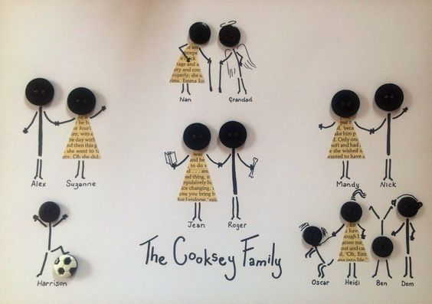
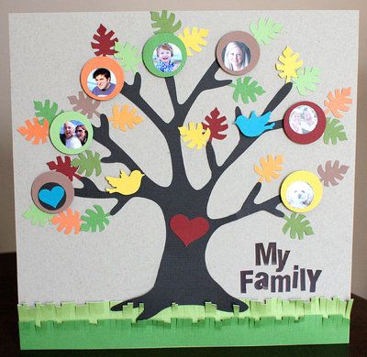
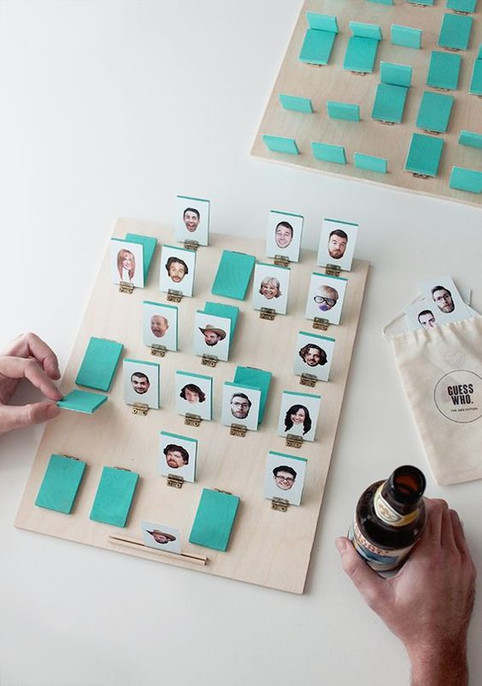
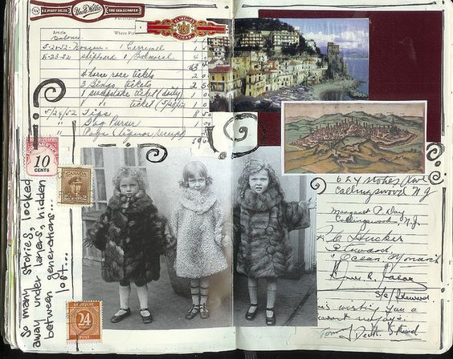

Wilford’s Diary:

“Thank you for your hospitality this week, Leila,” said Wilford.

This week Wilford is going home with Lottie.
He will return back to school after half term on Monday 31st October ☺.

Wilford is our class teddy bear and each week he will go home with a different child. He will bring his diary with him so that your child can write, draw and include photographs all about their adventures together. There is a welcome letter from Wilford at the front of the book that you can read through with your child.
Weekly Reminders:
Indoor PE every Wednesday afternoon. Outdoor PE every Tuesday afternoon.
*ABC PE each Friday (indoor kit required).* Autumn term only.
Tuesday – Tennis for those who have signed up.

Return to school on Monday 31st October.
Ferry Farm on Weds 2nd November – packed lunch required – no nuts please ☺

Homework due in: Friday 4th November 2016.

